Finding A Model of Inclusion in The Talmud
Based on the Teaching of Matan Koch and written by RespectAbility Staff and Fellows with the assistance of Howard Blas
March 11, 2022
For More Information Visit:
www.RespectAbility.org

Table of Contents
Table of Contents 1
Acknowledgments 2
1. Introduction 3
2. Limiting the Privileges of Disabled Priests 4
3. What Makes a Difference Distracting? 5
3.1. Unpacking the Source 5
3.2. Important Questions 5
4. The Principal Exception: Being Accustomed 6
4.1. An Exploration of Being Accustomed 6
4.2. Important Questions 6
5. Societal v. Individual Levels of “Accustomed” 7

Acknowledgments
RespectAbility would like to thank the donors and foundations who generously funded this project, as well as the other generous funders of its work, including Steven and Lisa Abramowitz; The Stanford and Joan Alexander Foundation; Sandy Baklor and Arlene Kaufman; Vivian and Raymond Bass; The Belz Foundation; The David Berg Foundation; Bernstein Family Foundation; John Bessonette; The Beverly Foundation; Stanley & Joyce Black Family Foundation; Linda and Andy Burger; Shelley and Ruvan Cohen; Cheri Fox; Friedel Family Foundation; Michael and Linda Frieze; Diane & Guilford Glazer Philanthropies; Margo Sim Gleitman; Lawrence S. and Phyllis C. Goldberg; Roberta Goldstein; Wayne Goldstein and Tara Slone-Goldstein; Nancy Grossman-Samuel; Andrew and Jan Groveman; Susan & Jeffrey Harris; Robert Horwitz; Aline and Leo Jacobsohn Foundation; Beatriz and Harold Jacobsohn; Jewish Community Foundation of Los Angeles; Laura Kam; Charles and Esther Lee Kimerling Charitable Foundation; Joseph & Phyllis Korff; John and Pat Laszlo; Nancy Laszlo; Levitt Foundation; Aaron and Ahuva Orlofsky; Gary and Esther Polland; Jarrow Rogovin; Ben and Esther Rosenbloom Foundation; Dr. Michael L. Ross and Elizabeth F. Ross; Yisroel and Rivka Schulman; The Charles & Lynn Schusterman Family Foundation; The Schwartz Creed Foundation; Marilyn Einstein and Steven Sim Charitable Fund; Ann and Andrew Tisch Family Fund; and the Weingart Foundation.

www.RespectAbility.org

Introduction
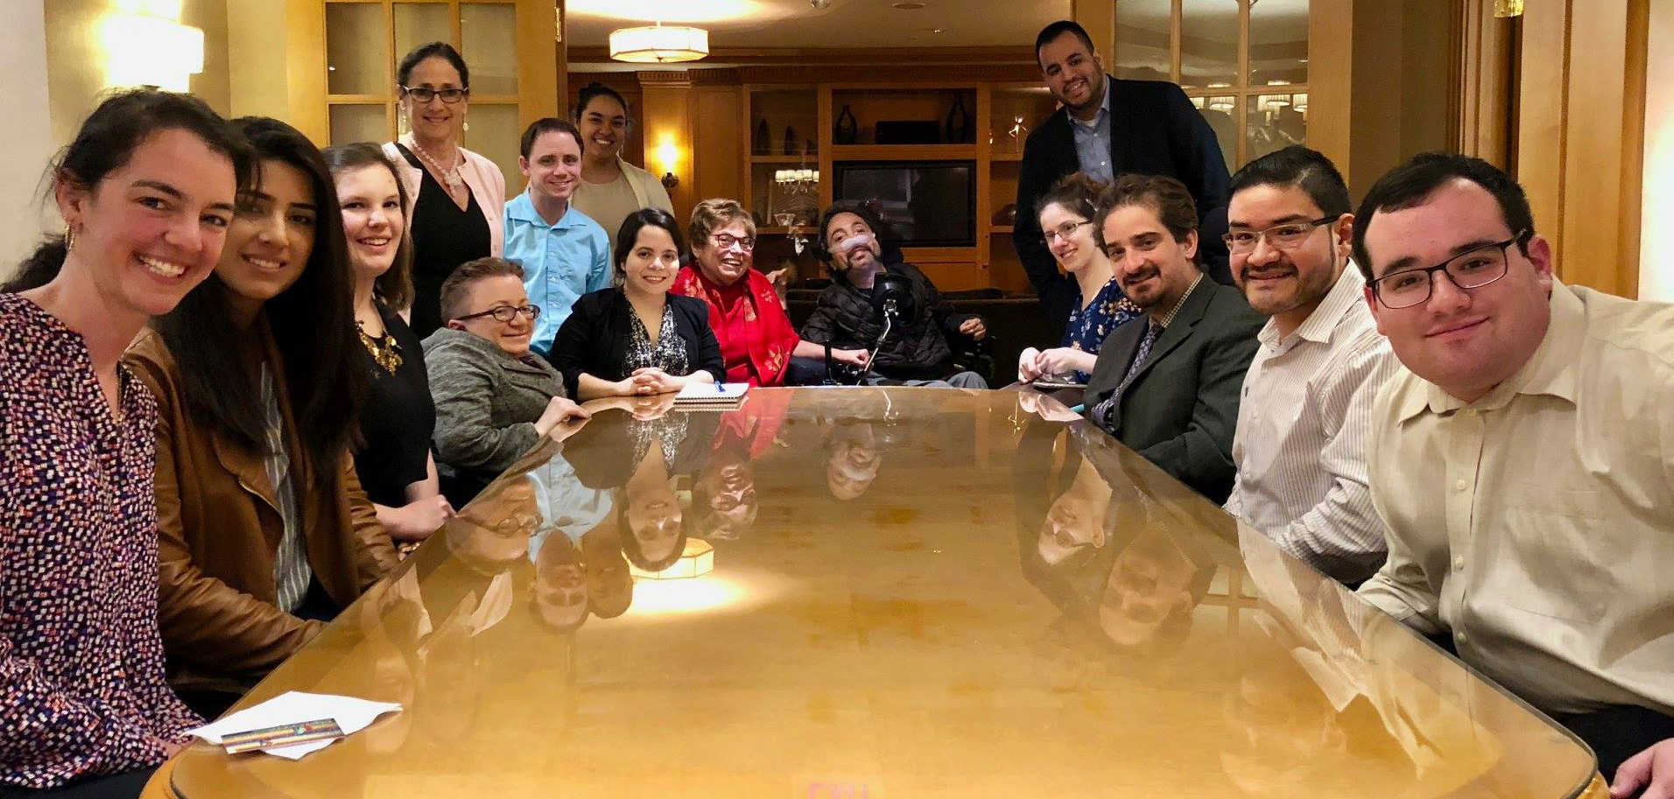
RespectAbility Staff and Apprentice Alumni smile seated around a table with Judith Heumann and Victor Pineda at the end

There are a number of text studies available from the RespectAbility designed to teach us about Jewish approaches to disability and about approaches to particular disabilities.
This advanced study, a modification of a popular workshop offered by Jewish scholar and RespectAbility VP Matan Koch, is a little different. It allows us to explore a Talmudic text as a way of guiding universal inclusion. The basic concept of universal inclusion is that we help communities remove barriers to better welcome all people and allow for full participation.
The point of this lesson is to explore excerpts from a Talmudic passage (Babylonian Talmud Megilla, 24b) which provides a clever and innovative rabbinic workaround to facilitate inclusion.

Limiting the Privileges of Disabled Priests
Mishnah: A priest whose hands are deformed should not lift up his hands [to say the priestly blessing]. R. Judah says: also, one whose hands are discolored with woad should not lift up his hands, because [this makes] the congregation look at him.
GEMARA. A Tanna stated: The deformities which were laid down [as disqualifying] are on the face, the hands and the feet. R. Joshua b. Levi said: If his hands are spotted he should not lift up his hands. It has been taught similarly: ‘If his hands are spotted, he should not lift up his hands. If they are curved inwards or bent sideways, he should not lift up his hands’ (Megillah 24b)
For those who do not know what a Mishna or Gemara are, here are some simple definitions:
Mishna: The original source from the oral Torah
Gemara: Rabbinic discussion and commentary on the source
The text begins by referring to the priestly blessing. A member of the priestly class, known as a kohain, would come up to the bima, or prayer platform. The congregants are supposed to bow their heads when this benediction is delivered. In the process, they do not look at the raised, cupped hands of the priests which are essentially over their heads.
This text is saying that anyone with “deformed hands” or with any noticeable difference should not lift their hands. Essentially, anything that could serve as a “distraction” and draw people’s attention away from God during the blessing would make the person disqualified. The cases mentioned here include a person with a physical disability of the hand(s) and one with hands colored with dye.
It is important to note that this is not calling out disability specifically, but anything that could be deemed “distracting.” However, the language used in these ancient texts does lend itself to different interpretations of what is considered a distraction. In this case, deformities seem to be one type of distraction.
Traditionally, one does not look at the Kohanim when they are blessing the congregation. The rabbis seem to be worried that people may look up, see hands which are “different”—either due to deformity or discoloration--and become distracted.
Instead of seeing something as a distraction during the blessing and taking away from focusing on God, we should approach this as recognizing that there will always be people in society who are different than us, who have different physical character traits than us, and appear different from us. And we should remember that we are all created in the image of God, just as God intended us to be. These differences should not be considered a distraction at all.

What Makes a Difference Distracting?
R. Assi said: A priest from Haifa or Beth Shean should not lift up his hands. It has been taught to the same effect: ‘We do not allow to pass before the ark either men from Beth Shean or from Haifa or from Tib'onim, because they pronounce ‘alif as ayin’ and ‘ayin as alif’.(continuation of Megillah24b)

Unpacking the Source
There’s a lot of fun stuff to learn about here that has nothing to do with inclusion. For anyone that likes Hebrew linguistic games, I encourage you to take some time to think about what happens if you swap Alephs for Ayins. In modern Hebrew, they are essentially both pronounced as silent letters. Among some Sephardic speakers of Hebrew, ayin is pronounced as much more guttural—from deeper down in the throat. In this discussion, they are saying that people in the Israeli cities of Haifa and Beth Shean had an accent. The way he pronounces these letters sounds different from what we are used to hearing.
Where the connection here is really made to the texts above is that this was considered to be a distraction--something that was unfamiliar to the listener. This helps us contextualize the notion of what society considers to be a distraction.
The bigger point is that people are being excluded from public leadership because they sound funny. Much like someone from the deep South might sound very different to someone from New England, it seems like people from these three cities sound very different to people wherever the authors were writing.

Important Questions
What do we think about the fact that the rabbis thought people might be confused by words due to their local dialect? Do we think there’s a place for making sure that the public is not confused by their prayer? Keep in mind, this was written at a time before prayer books, where there was a lot of call and response to Jewish prayer, and this was one’s way of praying.
There seems to be a difference between when call and response was the only way to engage in prayer, versus when prayer books became available. However, let's say that at a time where the only way of communicating and leading prayer was done by someone who maybe didn’t understand the language well and didn’t have a true understanding of what they were communicating. If so, then yes, maybe they shouldn’t be serving as prayer leaders.
On the flip side, assuming that someone knows exactly what they are saying, it comes down to figuring out a way to break down the barrier between what is being said and what is being understood. It is not that the priest or leader is unable to communicate effectively, but rather, there is a disconnect between what is being said and what is being understood.
If it is not a literal language barrier and there is nothing wrong with how the content is being communicated, then we must ask the question, is it a matter of not being confused by the familiar?

The Principal Exception: Being Accustomed
R. Huna said: A man whose eyes run should not lift up his hands. But was there not one in the neighborhood of R. Huna who used to spread forth his hands? — The townspeople had become accustomed to him. It has been taught to the same effect: ‘A man whose eyes run should not lift up his hands, but if the townspeople are accustomed to him, he is permitted’. R. Johanan said: A man blind in one eye should not lift up his hands. But was not there one in the neighborhood of R. Johanan who used to lift up his hands? — The townspeople were accustomed to him. It has been taught to the same effect: ‘A man blind in one eye should not lift up his hands, but if the townspeople are accustomed to him, he is permitted.’

An Exploration of Being Accustomed
Obviously, running eyes is some sort of distracting disability of the eyes which the rabbis of the Talmud felt disqualified someone then from reciting the priestly benediction.
But wait, as soon as they make the rule, they start talking about anecdotal exceptions where the townspeople had become accustomed to the individual and they were allowed to proceed! Then they give us another blanket rule for people blind in one eye, and immediately create an exception to that for people to whom the townspeople are accustomed.

Important Questions
What do you think they mean by “accustomed?”
Is it possible that if a community has become accustomed, then they will not be distracted, because they are familiar with the person and his condition and it is therefore no longer distracting?
If the determination is in fact individualized, perhaps it is not particular conditions like a disability that makes one unfit. Rather, it is the community’s inability to come to terms with this person and follow their leadership without distraction. It follows that we should all be on this journey. It further follows the prohibition, if any, should not be against populations who share a characteristic, but rather individually distracting people. This rule would evaluate everyone, but only exclude those who are actually distracting, diminishing exclusion in a community willing to accept a wider range of individuals.

Societal v. Individual Levels of “Accustomed”
R. Judah says: A man whose hands are discolored should not lift up his hands. A Tanna stated: If most of the men of the town follow the same occupation it is permitted.
This source starts with the restatement of our original Mishnah. Remember the idea that someone whose hands are discolored should also not publicly recite the benediction. But now we learn that an unnamed tanna, a sage, is telling us that this prohibition does not hold in a town where the majority of inhabitants have colored hands due to their profession as fabric dyers!
This is, that which is familiar is unlikely to be distracting and thus is not prohibited. In essence, if we see the disability not as a medical condition, but rather as a practical limiter on the lives of the individuals due to the way that society treats individuals with those medical conditions (colloquially known as the social model of disability), then the disabling sector is not the hands of the individual, but the distracted reaction by the observer.
Now you might say that this is a distinction without a difference, because we really can’t control our reaction to the new, unusual and misunderstood. It’s hardwired to keep us alive. At the same time, the human psyche is remarkably adaptable, and once it puts an individual or situation in the category of friend, suddenly we won’t be distracted. If that is the case, then shouldn’t we invest in training ourselves to experience people who are different is familiar, part of the diverse spectrum of humanity. Then no one is distracting, and so no one is prohibited.
In essence, this is a prohibition that we have the power to render obsolete. Arguably, the rabbis prioritize allowing Jewish people to fulfill their Jewish privileges and obligations. It seems to be an extension of this imperative to utilize the method that they gave us to remove the barrier posed by difference? Isn’t that really what we’re doing when we say we become accustomed? If so, may we achieve full acclamation soon.
Further, we should get on it posthaste, or at least have serious FOMO. What happens to an individual while they are waiting for the community become accustomed? Do you think they’ll stick around? I think the Talmud tells us to act before we find out.

