Created in the Image of God
A Jewish Exploration of People with Disabilities
Based on the Teaching of Matan Koch and written by RespectAbility Staff and Apprentices with the assistance of Howard Blas
March 11, 2022
For More Information Visit:
www.RespectAbility.org

Table of Contents
Table of Contents i
Acknowledgments ii
1. Introduction 1
2. General Overview: Key Ideas to Remember in this Text Study 1
3. What Exactly Did God Create? 2
3.1. What Can the Text Tell us About God’s Creation? 2
3.2. Mishnah Sanhedrin 4:5 2
3.3. Exodus Ch. 4 3
3.4. Tosefta Brachot 6:6 3
3.5. Pirkei Avot, Ethics of our Fathers, 4:3 4
4. The Difficulties of Disability 4
4.1. A Brief Introduction to the Social Model of Disability 4
4.2. What does this Model Mean for Us? 5
4.3. Taanit 19b-20a 5

Acknowledgments
RespectAbility would like to thank the donors and foundations who generously funded this project, as well as the other generous funders of its work, including Steven and Lisa Abramowitz; The Stanford and Joan Alexander Foundation; Sandy Baklor and Arlene Kaufman; Vivian and Raymond Bass; The Belz Foundation; The David Berg Foundation; Bernstein Family Foundation; John Bessonette; The Beverly Foundation; Stanley & Joyce Black Family Foundation; Linda and Andy Burger; Shelley and Ruvan Cohen; Cheri Fox; Friedel Family Foundation; Michael and Linda Frieze; Diane & Guilford Glazer Philanthropies; Margo Sim Gleitman; Lawrence S. and Phyllis C. Goldberg; Roberta Goldstein; Wayne Goldstein and Tara Slone-Goldstein; Nancy Grossman-Samuel; Andrew and Jan Groveman; Susan & Jeffrey Harris; Robert Horwitz; Aline and Leo Jacobsohn Foundation; Beatriz and Harold Jacobsohn; Jewish Community Foundation of Los Angeles; Laura Kam; Charles and Esther Lee Kimerling Charitable Foundation; Joseph & Phyllis Korff; John and Pat Laszlo; Nancy Laszlo; Levitt Foundation; Aaron and Ahuva Orlofsky; Gary and Esther Polland; Jarrow Rogovin; Ben and Esther Rosenbloom Foundation; Dr. Michael L. Ross and Elizabeth F. Ross; Yisroel and Rivka Schulman; The Charles & Lynn Schusterman Family Foundation; The Schwartz Creed Foundation; Marilyn Einstein and Steven Sim Charitable Fund; Ann and Andrew Tisch Family Fund; and the Weingart Foundation.

Introduction
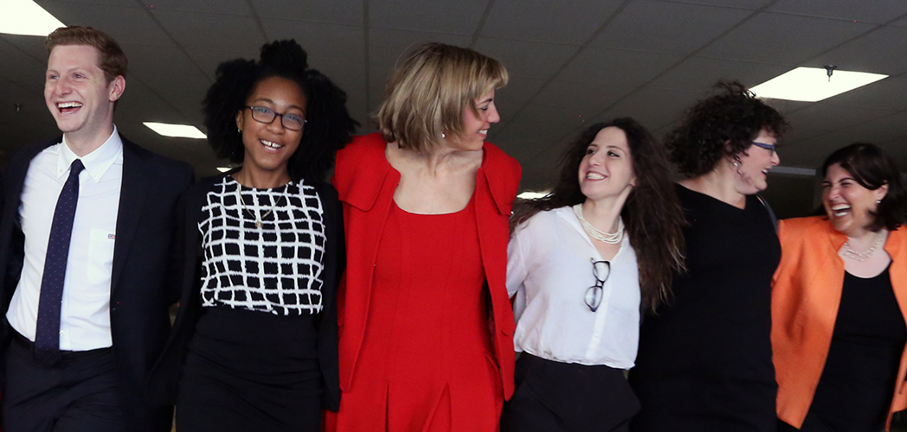
RespectAbility Jewish Apprentices and Staff
You are a human being created in the image of God. But what does this mean? Does God have a specific hair color, and only look like one person? If so, then we would all be looking like each other! This guide unpacks, what does it mean when we are told, we are created in the image of God, a divine image, and how can we connect that to how we think about disability?

General Overview: Key Ideas to Remember in this Text Study
Each of us, with all of our differences, is created by God to be exactly as we are.
Here we are looking at the social model of disability through a religious lens. The social model of disability is the notion that our inherent characteristics are not themselves disabilities, they are disabling because society was created around a norm that does not include us.
Let’s think about this for a minute. If there are no stairs in society, there is no disability if you need an alternative to stairs. These differences named above that we term “disability,” can’t inherently be bad. Rather, the challenges posed by disability must be independent of our own created perfection.
When we continue to look at disability through this lens and treat disability as an object of pity or ridicule, it is as though we are criticizing God. Right?--since God made us all the way we are, and intentionally so.

What Exactly Did God Create?

3.1. What Can the Text Tell us About God’s Creation?
Please keep in mind that these texts come directly from the Talmud, and are therefore using gendered language (i.e. “he” or “him”); however, since these texts were created, we have developed a lot as a society and are able to look at them through a non-gendered lens.
“And God created man in His image in the image of God He created Him” (Genesis 1:26- 27)
What does this mean? In what ways are we created in the image of God?
Let’s explore together.

3.2. Mishnah Sanhedrin 4:5
“An individual person was created to show the greatness of God. While a human being mints many coins from a single cast, and they are all identical. But the Holy One, blessed be God strikes us all from the mold of the first human, and each one of us is unique.”
The foregoing explanation from the rabbis in the Mishnah seems confusing. On the one hand, it appears that our individual characteristics are the very thing that make us great, our uniqueness is in our individual variation on the mold. How can this be? And how does this fit with us being created in God’s image?
It might be easy to explain away creation in God’s image as focusing on our shared strengths, our ability to love, our seeking of the holy, our inclination to good. And yet, though those shared strengths are wonderful, they are but one component of who we are. Further neither they, nor our shared weaknesses, appear to be the true demonstration of the greatness of God. Rather, however, this Mishnah tells us that the greatness comes from that which makes us unique. Why might this be?
God is vast, complex, and infinite. In some ways, it is difficult to conceive how the small mortal person could in fact reflect the image of God. And yet, we also know that there are currently 8 billion people in the world, and that a conservative estimate of all humans ever to have lived in several multiples of that. Perhaps it is only when you add up each of our individual unique features, in addition to our shared features, that we come close to reflecting the image of God. Seen that way, disability is not only an intentional creation, it is an intentional variation given to the created so that we collectively may more greatly reflect the image of God, which after all is large enough to encompass all features and all disabilities. The upshot is this: Disability is really a part of God’s plan. Let’s look at a familiar story that sheds some light on this question:

3.3. Exodus Ch. 4
10: “And Moses said to God: ‘Please God, I am not a man of words, nor have I ever been, even since You have spoken to Your servant; for I am of a heavy mouth and a heavy tongue.'
11: And God said to him: ‘Who makes a man’s mouth? Or makes him dumb, or deaf, or seeing, or blind? Is it not I God?
12: Now go, and I will be with your mouth, and teach you what you will say.” (Exodus 4:10-12)
Just to be clear, God is saying, “I built this, I know who you are. I made you just as you are, and what you are is exactly what I need.”
Moses’ heavy mouth, or slowness of speech and tongue, which is often described as a speech disability, is exactly how God intended Moses to be. We can ponder why God created Moses as he did with a speech disability. Was it in order that someone could have all of the privilege of growing up in the house of the Pharoah, but also know what it was to struggle? Was it so that Moses would need the accommodation of Aaron, to teach that none of us can really act alone? Maybe, but all we know for sure, is that God made Moses intentionally the way he is.
As each of us is different, we are all created just as God intended us to be: in God’s own image.
The ancient rabbis seem to get this, and are quite comfortable with discussing God’s origin for disability. Let’s explore our next text:

3.4. Tosefta Brachot 6:6
“One who sees a Cushite or an albino, or [a man] red-spotted in the face, or [a man] white-spotted in the face [a man afflicted with psoriasis or elephantiasis], or a hunchback, or a dwarf (or a deaf man or an imbecile, or a drunk) says (the blessing) “Blessed is the One who created such varied creatures. [One who sees] an amputee, or a lame man, or a blind man, or a man afflicted with boils, says (the blessing) “Blessed Be the True Judge.”
By way of background, “Blessed be the True Judge” is the traditional blessing to offer to one who has experienced a loss. A “Cushite” refers to someone from Africa and has darker skin and different features from which the person reciting the blessing was accustomed.
You may wonder why encountering someone who is blind requires the “True Judge” blessing. The determining factor appears to be between things you are born with (blessing 1) and things which occur over the course of one’s life (blessing 2).
With disabilities from birth, it was understood that they were just the part of being created in God’s image, a part of the mold. However, with acquired disabilities, it feels like more of a loss, therefore the 2nd blessing. The person may be grieving their former self and their former life, even as they begin to accept it.
Is it possible that we are expressing sympathy not for the state of disability, but for the need to adjust to changed circumstances? We don’t question God’s plan, which is the nature of blessing God’s judgment; at the same time, we don’t fully celebrate because we understand that the change is difficult for the individual.

3.5. Pirkei Avot, Ethics of our Fathers, 4:3
Based on the texts and analysis in this guide so far, we can take away the idea that everyone and everything is special and has a place in this world.
"Ben Azzai taught: "Treat no one lightly and think nothing is useless, for everyone has a moment and everything has a place."
The Moses story allows for the possibility that Moses’s disability made him perfectly suited to receive God’s instruction. The ancient rabbis understood that everything has its place in the world. Each person with and without disabilities brings a uniqueness to the world.

The Difficulties of Disability
The previous sources leave us with a burning question. Having a disability can be hard. The disability rights movement is, at its heart, simply a push for those of us who experience disabilities to have the same rights and opportunities as everyone else. Given these challenges though, it’s reasonable to ask how disability could be part of the intentions of a merciful God. This section will use both social theory and Jewish text to explore the idea that disability may be a part of God’s plan while the difficulty and challenge currently faced by people with disabilities results from stigma and prejudice.

A Brief Introduction to the Social Model of Disability
In a world where everything is designed to be wheelchair accessible, is it really disabling to use a wheelchair?
In a world where all information and data are available in both visual and auditory forms, is it disabling to be blind? No!
Social scientists call this the social model of disability, which is to say that certain conditions or differences become disabling because of the choices that our society makes. Society itself has the potential to create a world which is easier or more difficult for people to navigate.
What do we think about this idea?
Perhaps it is better to think that the difficulties posed by the way God chose to create us stem from imperfections in the world as opposed to imperfections in the person.

What does this Model Mean for Us?
“You shall not curse the deaf or put a stumbling block before the blind. You shall fear your God: I am Adonai.” (Leviticus 19:14)
Usually, we think about this famous biblical quote as an admonition not to mistreat people who are deaf or blind. In light of everything that we’ve just discussed, who thinks it could be more?
Could being blind be a neutral thing which becomes a serious problem only when someone puts a stumbling block in front of him or her?
Could being deaf be a neutral thing, but when you are being cursed and lack the ability to hear and therefore don’t even know that it is happening, that it then becomes a bad thing?
What if our obligation isn’t just to be nice and treat people well, and not place things in front of someone who cannot see, but to make sure that we don’t make collective or individual decisions that make their state of being disabling? Something is not disabling unless someone turns an inherent condition into a disability. Having explored all of this, let’s now look at the text that synthesizes everything:

Taanit 19b-20a
“Once, when Rabbi Elazar the son of Rabbi Shimon [bar Yohai] left Migdal Gadur, his teacher’s house, he rode on his donkey, moving along the bank of the river, extremely happy, and in a strutting frame of mind, because he had learnt so much Torah. He happened across an extremely ugly man. The man said, ‘Shalom, my teacher.’ Rabbi Elazar did not answer him; instead he said, “Idiot! How ugly that man [i.e. you] is! Could it be that everyone in your city is as ugly as you?!’ The man said, ‘I do not know; why don’t you go to the artisan who made me and say, ‘How ugly that vessel You made is..!’ When Rabbi Simeon realized that he had done wrong, he dismounted from his donkey and fell down at the man’s feet, saying, ‘I fully accept – please forgive me.’ ‘I will not forgive you,” said the man, “until you go to that Artist who made me and tell him, ‘How ugly that vessel is that You made.”
How does this text synthesize everything that we have learned so far? Well, Rabbi Elazar is saying that Rabbi Simeon must go and apologize to the one who created Rabbi Elazar, not to Rabbi Elazar alone. But who created Rabbi Elazar? God created Rabbi Elazar, just as he created each and every one of us to be our own individual entities.
Essentially, when Rabbi Simeon is criticizing Rabbi Elazar, he is criticizing the work of God, since we are all created in the Image of God, and we are all God’s work.
To fully grasp and understand these texts, we must look at them with the assumption that God created each person with value and with a particular destiny. When we criticize and minimize that plan, we are criticizing God and God’s plan.

