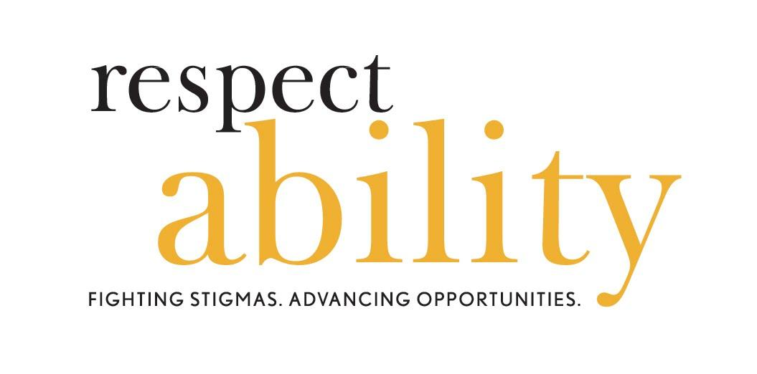
VOLUNTEER HANDBOOK

“Alone we can do so little; together we can do so much.” –– Helen Keller

Table of Contents
Welcome to the Team! 1
1. RespectAbility’s Policies 2
1.1. Equal Employment Opportunity and Harassment 2
1.2. Reimbursement of Expenses 5
1.3. Procedure for Removal of a Volunteer and Return of Property 5
1.4. Conflict of Interest 6
1.5. Nondisclosure of Confidential Information 6
1.6. Intellectual Property 7
1.7. Dress Code 7
1.8. Drug and Alcohol Policy 7
1.9. Non-Smoking Environment 7
1.10. Violence in the Workplace 8
1.11. Standards of Conduct and Ethics 8
1.12. Nonprofit Status 9
1.13. Media Policy 9
2. Disability FAQ 11
3. Sample of Team Activities 18
3.1. Education & Skills Building Team 18
3.2. Jobs for People with Disabilities Team 19
3.3. Stigma Reduction / Disability in Hollywood Team 20
3.4. Intersection of Politics and Disability Team 21
3.5. Inclusive Philanthropy Team 22
3.6. National Leadership Program Team 24
3.7. Spanish-Language Resource Team 25
3.8. Jewish Inclusion Team 27
4. Volunteer Forms 28
4.1. Volunteer Confidentiality Form 29
4.2. Emergency Contact Form 31
4.3. Receipt of Volunteer Handbook Acknowledgement Form 32
4.4. Photo and Audio Release Form 33
4.5. Volunteer Valuation Form 34
5. Terminology Tips: Using the Appropriate Lexicon 36
6. Common Acronyms 38
7. Etiquette: Interacting With People With Disabilities 40

Welcome to the Team!
Greetings!
On behalf of our full board and staff, we are so pleased that you are ready to join RespectAbility’s mission to fight stigmas and advances opportunities for people with disabilities.
We truly appreciate volunteers – whether we work a few hours or many – in creating positive change. We appreciate that you are willing to bring your time and talent to this cause and look forward to working with you!
One out of five Americans lives with a disability. We are the largest minority in the nation, and a minority that anyone can join at any time, given that injuries, illness, and aging are potential realities for us all. I myself have a disability and loved ones with disabilities. Together, we can make real changes.
Whether you yourself have a disability, as I do; or whether you deeply care about someone with a disability, as I do; or whether you simply want to fight implicit bias and create opportunities for people with disabilities, as all of us at RespectAbility do; we are happy that you have joined us to enable people with disabilities to have a better future. We want you to have a wonderful experience with our team and this cause.
To end by quoting Helen Keller – a deeply important leader, author, political activist, lecturer who was also deaf-blind – “Alone we can do so little; together we can do so much.” Together, we continue to do the work that still awaits our doing. Together, we can cultivate a more accessible and inclusive nation and world. Welcome aboard, and let’s get going!
Respectfully,
Jennifer Laszlo Mizrahi
President, RespectAbility

For More Information:
Ben Spangenberg, BenS@RespectAbility.org
www.RespectAbility.org

RespectAbility’s Policies
RespectAbility knows we are stronger and better when we are accepting, welcoming and respectful of all people. Since Day One, RespectAbility had board-approved, intentional diversity and equality policies. We are a “Nothing About Us Without Us” organization.
RespectAbility provides equal employment opportunities (EEO) to all employees and applicants for employment without regard to race, color, religion, gender, sexual orientation, gender identity or expression, national origin, age, disability, veteran status or genetics. In addition to federal law requirements, RespectAbility complies with applicable state and local laws governing nondiscrimination in employment. This policy applies to all terms and conditions of employment, including recruiting, hiring, placement, promotion, termination, layoff, recall, transfer, leaves of absence, compensation and training.
RespectAbility has a commitment to individual and organizational efforts to build respect, dignity, fairness, compassion, equality and self-esteem in order to create an environment that is inclusive of all throughout our organization and the disability community. We acknowledge and honor the fundamental value and dignity of all individuals. We pledge ourselves to creating and maintaining an environment that respects diverse traditions, heritages and experiences.
RespectAbility’s Code of Conduct (hereinafter referred to as the Code) requires directors, other volunteers and employees to observe high standards of business and personal ethics in the conduct of their duties and responsibilities. Employees and representatives of the organization must practice honesty and integrity in fulfilling their responsibilities and comply with all applicable laws and regulations.

Equal Employment Opportunity and Harassment
The RespectAbility Volunteer Handbook (the “Handbook”) has been developed to provide general guidelines about RespectAbility policies and procedures for volunteers. It is a guide to assist you in becoming familiar with some of the privileges and obligations of your volunteering with us.
The policies of RespectAbility are established by the Board of Directors, which has delegated authority and responsibility for their administration to the President. The President may, in turn, delegate authority for administering specific policies. Volunteers are encouraged to consult the Director of Community Outreach & Impact for additional information regarding the policies, procedures, and privileges described in this Handbook.
RespectAbility will provide a copy of this Handbook in electronic and paper version upon acceptance as a volunteer. All volunteers are expected to abide by it. Because of the nature of the business that RespectAbility is conducting, the highest standards of personal and professional ethics and behavior are expected of all RespectAbility volunteers. Further, RespectAbility expects each volunteer to display good judgment, diplomacy and courtesy in their professional relationships with members of RespectAbility's Board of Directors, teams, membership, staff, other volunteers, and the general public.

Equal Opportunity
RespectAbility is committed to complying fully with applicable disability discrimination laws, and ensuring that equal opportunity exists at RespectAbility for qualified persons with disabilities – employees and volunteers alike. All of RespectAbility’s practices and activities are conducted on a non-discriminatory basis. Reasonable accommodations will be available to all qualified disabled employees or volunteers, upon request, so long as the potential accommodation does not create an undue hardship on RespectAbility. Volunteers who believe that they may require an accommodation should discuss these needs with the Director of Community Outreach & Impact.
RespectAbility has been recognized by Slingshot as an organization at the highest level. We also are recognized by Guide Star at the Platinum level for our inclusion, transparency and excellence.

Policy Against Workplace Sexual and Other Harassment
RespectAbility is committed to providing a work environment for all folks that is free from sexual harassment and other types of discriminatory harassment. Volunteers are expected to conduct themselves in a professional manner and to show respect for everyone. RespectAbility’s commitment begins with the recognition and acknowledgment that sexual harassment and other types of discriminatory harassment are unlawful and will not be tolerated.
To reinforce this commitment, RespectAbility has developed a policy against harassment and a reporting procedure for employees and volunteers who have been subjected to – or who have witnessed – harassment. This policy applies to all work-related settings and activities, whether inside or outside the workplace, and includes business trips and business-related social events. RespectAbility’s property (e.g. telephones, copy machines, facsimile machines, computers, and computer applications such as e-mail and Internet access) may not be used to engage in conduct that violates this policy. RespectAbility’s policy against harassment covers employees, volunteers, and other individuals who have a relationship with RespectAbility, which enables RespectAbility to exercise some control over the individual’s conduct in places and activities that relate to RespectAbility’s work (e.g. directors, officers, contractors, vendors, volunteers, etc.
RespectAbility’s policy against sexual harassment prohibits sexual advances or requests for sexual favors or other physical or verbal conduct of a sexual nature, when: (1) submission to such conduct is made an express or implicit condition of employment or service; (2) submission to or rejection of such conduct is used as a basis for employment or service decisions affecting the individual who submits to or rejects such conduct; or (3) such conduct has the purpose or effect of unreasonably interfering with any other person’s work performance or creating an intimidating, hostile, humiliating, or offensive working environment.
While it is not possible to list all of the circumstances which would constitute sexual harassment, the following are some examples: (1) unwelcome sexual advances -- whether they involve physical touching or not; (2) requests for sexual favors in exchange for actual or promised job benefits such as favorable reviews, salary increases, promotions, increased benefits, or continued employment; or (3) coerced sexual acts.
Depending on the circumstances, the following conduct may also constitute sexual harassment: (1) use of sexual epithets, jokes, written or oral references to sexual conduct, gossip regarding one’s sex life; (2) sexually oriented comment on an individual’s body, comment about an individual’s sexual activity, deficiencies, or prowess; (3) displaying sexually suggestive objects, pictures, illustrations, and/or cartoons electronically or otherwise; (4) unwelcome leering, whistling, inappropriate staring, deliberate brushing against the body in a suggestive manner; (5) sexual gestures or sexually suggestive comments; (6) inquiries into one’s sexual experiences; or (7) discussion of one’s sexual activities.
While such behavior, depending on the circumstances, may not be severe or pervasive enough to create a sexually hostile work environment, it can nonetheless make others uncomfortable. Accordingly, such behavior is inappropriate and may result in disciplinary action regardless of whether it is unlawful. It is also unlawful and expressly against RespectAbility policy to retaliate against an employee or volunteer for filing a complaint of sexual harassment or for cooperating with an investigation of a complaint of sexual harassment.
Prohibition of Other Types of Discriminatory Harassment: It also is against RespectAbility’s policy to engage in verbal or physical conduct that denigrates or shows hostility or aversion toward an individual because of his or her race, color, gender, religion, sexual orientation, age, national origin, disability, veteran status, or other protected category (or that of the individual’s relatives, friends, or associates) that: (1) has the purpose or effect of creating an intimidating, hostile, humiliating, or offensive working environment; (2) has the purpose or effect of unreasonably interfering with an individual’s work performance; or (3) otherwise adversely affects an individual’s employment or service opportunities.
Depending on the circumstances, the following conduct may constitute discriminatory harassment: (1) epithets, slurs, negative stereotyping, jokes; or threatening, intimidating, or hostile acts that relate to race, color, gender, religion, sexual orientation, age, national origin, disability, or veteran status; and/or (2) written or graphic material that denigrates or shows hostility toward an individual or group because of race, color, gender, religion, sexual orientation, age, national origin, disability, or veteran status and that is circulated in the workplace, or placed anywhere in RespectAbility’s premises such as on a desk or workspace or on RespectAbility’s equipment or bulletin boards. Other conduct may also constitute discriminatory harassment if it falls within the definition of discriminatory harassment set forth above. It is also against RespectAbility’s policy to retaliate against an employee or volunteer for filing a complaint of discriminatory harassment or for cooperating in an investigation of a complaint of discriminatory harassment.
Reporting of Harassment: If you believe that you have experienced or witnessed sexual harassment or other discriminatory harassment by any employee, volunteer, Board member, donor, or prospective donor of RespectAbility, you should report the incident immediately to your supervisor or to the President. Possible harassment by others with whom RespectAbility has a business relationship, including customers and vendors, should also be reported as soon as possible so that appropriate action can be taken.
RespectAbility will promptly and thoroughly investigate all reports of harassment as discreetly and confidentially as practicable. The investigation would generally include a private interview with the person making a report of harassment. It would also generally be necessary to discuss allegations of harassment with the accused individual and others who may have information relevant to the investigation. RespectAbility’s goal is to conduct a thorough investigation, to determine whether harassment occurred, and to determine what action to take if it is determined that improper behavior occurred.
If RespectAbility determines that a violation of this policy has occurred, it will take appropriate disciplinary action against the offending party, which can include counseling, warnings, suspensions, and termination. Employees or volunteers who report violations of this policy and employees or volunteers who cooperate with investigations into alleged violations of this policy will not be subject to retaliation. Upon completion of the investigation, RespectAbility will inform the employee or volunteer who made the complaint of the results of the investigation. Compliance with this policy is a condition of each employee’s employment or volunteer service. Employees and volunteers are encouraged to raise any questions or concerns about this policy or about possible discriminatory harassment with the President.

Reimbursement of Expenses
Any expenses authorized in advance, in writing, by the RespectAbility staff and paid by the volunteer will be reimbursed upon receipt of copies of expenses. All items should be documented for reimbursement.

Procedure for Removal of a Volunteer and Return of Property
RespectAbility is so grateful for the time and talents our volunteers share with our program and we hope to maintain that level, however there are several reasons that a volunteer would be asked to leave RespectAbility. They include but are not limited to:
- Violation of one of the policies included in Orientation Training OR this manual,
- Disrespecting another volunteer, staff member, fellow, board member, or any other individual.
- Presence at RespectAbility or any events under the influence of alcohol or an illegal substance.
- Conviction of a crime or being charged with sexual abuse.
- Causing a conflict or disruption of work.
Violation of our confidentiality agreement.
Any professional staff person or board member may remove a volunteer from our program.
Should a volunteer be accused of one of the above offenses or face removal from the program, a review by our president may be requested.
Volunteers are responsible for RespectAbility equipment, property and work products that may be issued to them and/or are in their possession or control, including but not limited to:
Telephone cards, corporate credit cards, Identification badges, Office/building keys, Office/building security passes, mobile phones, computers, thumb drives, external backup drives and related items, electronic/voice mail codes, and Intellectual property (e.g., written materials, work products).
In the event of separation from volunteer service, or immediately upon request by the President or his or her designee, volunteers must return all RespectAbility property that is in their possession or control. RespectAbility may take any action deemed appropriate to recover or protect its property.
All files of RespectAbility, in paper or electronic form, including donor and activist lists, press lists and other lists and compilations of information prepared by or for the organization, are property of RespectAbility and must be returned to RespectAbility upon termination of volunteer service for any reason. Volunteers may not retain copies of any such files, lists or information without the express prior permission of the President of RespectAbility.

Conflict of Interest
It is the policy of RespectAbility to prohibit volunteers from engaging in any other business that competes with RespectAbility. Also, RespectAbility prohibits volunteers from having a financial interest in an outside concern which does business with or is a competitor of RespectAbility (except where such interests consists of holding securities of a publicly owned corporation regularly traded on the public stock market). Rendering of managerial or consulting services to any outside concern which does business with, or is working against the goals of RespectAbility is also prohibited. If you think that there is a possibility that you may have a conflict as described above, it is your responsibility to notify your immediate supervisor and obtain prior approval in writing.

Nondisclosure of Confidential Information
Any information that a volunteer learns about RespectAbility, or its members or donors, as a result of service for RespectAbility that is not otherwise publicly available constitutes confidential information. Volunteers may not disclose confidential information to anyone who is not employed by RespectAbility or to other persons employed by RespectAbility who do not need to know such information to assist in rendering service. All records and files of RespectAbility are considered confidential. No volunteer is authorized to copy or disclose any file, record or any part without permission of the Director. Confidential information includes but is not limited to financial information and reports, lists of donors and potential donors, memos, e-mails, etc. relating to RespectAbility strategy, plans, projects or operations; any files, letters, memos, etc. concerning transactions with donors, staff and board, payroll or personnel records of past or present employees, all records pertaining to purchases from vendor or suppliers, engineering drawings, correspondence and agreements with manufacturers or distributors and documents concerning operating procedures of RespectAbility, all regardless of form, whether written or electronic or verbal.
Volunteers are required to sign a non-disclosure agreement as a condition of volunteer service. Discussions involving sensitive information should always be held in confidential settings to safeguard the confidentiality of the information.

Intellectual Property
As an volunteer of RespectAbility, it shall be understood and you agree that all lists, writings, materials, audiovisual works and other works in any form whatsoever, whether written, electronic or otherwise, created or produced by you in the course of the performance of services for RespectAbility shall become and remain the exclusive property of RespectAbility and shall be deemed works for hire created for RespectAbility for purposes of the Copyright Law of 1976 and as may be amended; and all copyright and any other rights in and to such writings, materials and works shall belong to RespectAbility. As a volunteer you agree to execute and deliver any instrument of conveyance or any other instrument or document necessary to transfer all such rights to RespectAbility unless otherwise agreed to by the President.

Dress Code
RespectAbility strives to project a professional image at all times, but especially when RespectAbility volunteers are attending meetings with elected officials and key decision makers. When representing RespectAbility, dress slacks/pants/skirts with dress shirts or polo shirts are appropriate. Shorts, flip-flops, floppy sandals, t-shirts with logos/writing or any other such casual attire is inappropriate for the office or elsewhere, when representing RespectAbility. We will provide RespectAbilty volunteers with pins that identify them as being members of our team. It is also frequently helpful to wear nametags.

Drug and Alcohol Policy
The possession, consumption, purchase or sale of an illegal drug on the premises of RespectAbility is prohibited. Consumption of alcohol may only be done as part of a specifically approved event (i.e. a fundraising dinner) that is outside of the RespectAbility offices. Furthermore, no volunteer shall be under the influence of alcohol or an illegal drug while on RespectAbility premises, while operating equipment, or while performing business off premises. An “illegal drug” is a drug or controlled substance which is (1) not legally obtainable, or (2) legally obtainable, but not obtained or used in a lawful manner.

Non-Smoking Environment
RespectAbility is committed to providing a safe and healthy work environment for its employees, business associates and community members. For this reason, there is a complete ban on smoking, including e-cigarettes, in our workplace, and/or when at events representing RespectAbility.
Smoking is prohibited anywhere in the office including general access areas such as stairwells, hallways, restrooms and conference rooms.

Violence in the Workplace
RespectAbility has a zero tolerance policy for violence. If you display any violence in the workplace or threaten violence in the workplace or when representing RespectAbility, you will be subject to termination. Talking of violence or joking about violence will not be tolerated. You are encouraged to confidentially report any potential or actual violent incident immediately to your supervisor.

Standards of Conduct and Ethics
Volunteers in any organization are expected to observe certain standards of job performance and acceptable conduct. While RespectAbility cannot list every possible area of unacceptable conduct, set forth below are examples of conduct which will not be acceptable in the work environment and may result in immediate termination of volunteer service without notice.

Gross Misconduct
- Failure to follow safety policy or procedures.
- Dishonesty.
- Rudeness or lack of cooperation with employees, customers, or vendors.
- Theft of company property or the personal property of others.
- Falsifying or altering RespectAbility records including employment application, time sheets or medical documents.
- Altercations, fighting, threatening, or intimidating others.
- Insubordination.
- Violation of RespectAbility’s policy against discrimination and harassment.
- Retaliating against any person who makes a complaint or participates in an investigation relating to RespectAblity’s policy against discrimination and harassment.
- Violation of the policy against Violence in the Workplace.
- Being under the influence of, using, possessing or selling alcohol or illegal controlled substances on RespectAbility’s property or while conducting business for RespectAbility.
- Gambling on RespectAbility’s property or while conducting RespectAbility business.
- Possessing a firearm or other dangerous weapons on RespectAbility’s property or while conducting RespectAbility business.
- Being convicted of a crime.
- Disclosing company confidential or proprietary information to unauthorized persons.
Obtaining confidential or proprietary information without permission from the President.

Nonprofit Status
RespectAbility is recognized as a nonprofit corporation under the U.S. tax code section 501(c)(3). Like other charitable, religious, educational, or scientific organizations with this status, individuals who make contributions to RespectAbility may, with certain limitations, receive tax deductions for those donations. In exchange for this status, nonprofit organizations must adhere to certain important restrictions on their activities. There is an absolute prohibition on any activities that could be construed as intervening on behalf of or in opposition to any candidate for public office. Nonprofits must also agree not to devote a substantial amount of organization activities to lobbying.
In your capacity as a volunteer representing RespectAbility, you should refrain from any activities on behalf of or in opposition to a candidate for public office or any efforts that could be interpreted as intervening or participating in an electoral campaign on behalf of RespectAbility.
NO volunteer should (1) make any public statement of any kind, or prepare or disseminate any public communication (media, press release, brochure, etc.) referring to any candidate for public office, on behalf of RespectAbility, without first consulting your supervisor or, as directed by your supervisor, and legal counsel or (2) invite any candidate for public office to any RespectAbility event without first consulting your supervisor or, as directed by your supervisor and legal counsel.
You may not, while on duty for RespectAbility or using the name or resources of RespectAbility, encourage membership in any particular political party, share lists or in any way support a party or candidate, including permitting the use of telephones, equipment, etc.
You should not provide or sponsor any candidate questionnaires or voting records without approval from RespectAbility’s President or designated staff person.

Media Policy
To ensure the quality and consistency of RespectAbility information disseminated to media sources, the following policy shall be enforced:
- All media contacts are to be handled by the President, or designee, regardless of who the media representative is, whom he or she represents, or how innocuous the request.
All press releases or other promotional materials are to be approved by the President or designee prior to dissemination. Failure to comply with RespectAbility’s media policy shall be grounds for disciplinary action.

Electronic and Social Media Policy
- RespectAbility has established a policy regarding the use of electronic communications such as, facsimiles, computers, voice mail, Internet, Skype, Twitter, Facebook, Instagram, email and telephones in an effort to make certain that employees and volunteers utilize electronic communication devices in a legal, ethical, and appropriate manner.
- It may not be possible to identify every standard and rule applicable to the use of electronic communications devices. Volunteers therefore are encouraged to utilize sound judgment whenever using any feature of the communications system. If there is any question, concern or hesitation, to a) discuss it with a RespectAbility staff member, and b) err on the side of caution.
It is highly encouraged to share content that RespectAbility has created or shared on our social media.
However, should you choose to post any other non RespectAbility related content via social media, do not attribute it to RespectAbility without prior written permission from RespectAbility staff.
Any taking of, or use of, photographs involving children, under the age of 18, require a signed and dated release from a parent or in loco parentis (ie, person with legal right to sign release). (Form to be found in section seven).

Disability FAQ
What is considered a disability?
According to the Americans with Disabilities Act, an individual with a disability is a person who (1) has a physical or mental impairment that substantially limits one or more "major life activities," (2) has a record of such an impairment, or (3) is regarded as having such an impairment.
The ADA does not set forth an exclusive list of conditions it covers. The regulations define "physical or mental impairment" as any physiological disorder or condition, cosmetic disfigurement or anatomical loss affecting one or more body systems, such as neurological, musculoskeletal, special sense organs, respiratory (including speech organs), cardiovascular, reproductive, digestive, genitourinary, immune, circulatory, hemic, lymphatic, skin and endocrine. The regulations also cover any mental or psychological disorder, such as intellectual disability, organic brain syndrome, emotional or mental illness and specific learning disabilities.
Although there is not an exhaustive list of disabilities under the ADA, the regulations identify medical conditions that would easily be considered a disability within the meaning of the law. These medical conditions include:
Auditory processing challenges
Autism
Bipolar disorder
Blindness
Cancer
Cerebral palsy
Deafness
Diabetes
Epilepsy
HIV infection
Intellectual disabilities
Major depressive disorder
Mobility impairments requiring the use of a wheelchair
Multiple sclerosis
Muscular dystrophy
Obsessive-compulsive disorder
Partial or completely missing limbs
Post-traumatic stress disorder
Schizophrenia
Sensory processing challenges
Major life activities are functions like caring for yourself, bathing, dressing, shaving, preparing a meal, going to the restroom, performing manual tasks, eating, sleeping, standing, walking, lifting, reaching, bending, seeing, hearing, speaking, breathing, learning, reading, concentrating, thinking, communicating, interacting with others and working.
As a result of the Americans with Disabilities Amendments Act, major life activities now include the operation of any major bodily function, like functions of the immune system, normal cell growth, digestive, bowel, bladder, neurological, brain, respiratory, circulatory, endocrine and reproductive (procreation) functions, among others.
In the context of the ADA, “disability” is a legal term rather than a medical one. Because “disability” has a legal definition, the ADA’s definition of disability differs from how disability is defined under some other laws.
What is the Americans with Disabilities Act (ADA)?
The ADA is the nation's primary disability nondiscrimination law. It became law in 1990. It is a civil rights law that prohibits discrimination against individuals with disabilities in all areas of public life, including jobs, schools, transportation and all public and private places that are open to the general public.
The purpose of the law is to make sure that people with disabilities have the same rights and opportunities as everyone else. The ADA gives civil rights protections to individuals with disabilities similar to those provided to individuals on the basis of race, color, sex, national origin, age and religion. It guarantees equal opportunity for individuals with disabilities in public accommodations, employment, transportation, state and local government services, and telecommunications. The ADA is divided into five titles (or sections) that relate to different areas of public life.
In 2008, the ADA was amended and thus is referred to as the Americans with Disabilities Amendments Act (ADAAA) in certain contexts. There are ADA centers around the country that can assist you: https://adata.org/find-your-region.
What is ableism?
Ableism is discrimination in favor of people without disabilities. It is the belief that people who have disabilities are somehow less human, less valuable and less capable than others.
What is an inclusion rider? How can they help people with disabilities in Hollywood?
An inclusion rider is a provision that ensures diversity and inclusion in not only the cast of a Hollywood project but also the crew. The result can lead to a Hollywood A-list actor or studio ensuring gender, racial, LGBTQ and disability equality via his or her employment contracts. Equitable hiring can lead to equal roles and pay for women, people of color, the LGBT community and performers with disabilities. An inclusion rider is available to anyone who does a negotiation on a film. Inclusion riders can help eliminate bias in the hiring and casting process and would produce films that more accurately reflect real-world diversity. Riders can be applicable to conferences and speaking engagements. But many actors talking about the inclusion rider today are doing so in the context of ethnicities, races and sexual orientations – leaving out the one-in-five Americans with a disability. This minority group – the largest minority in the U.S. – needs to be included in all Inclusion Riders.
What is person-first language? Does everyone use it?
Person-first or people-first language is a way of describing disability that involves putting the word "person" or "people" before the word "disability" or the name of a disability, rather than placing the disability first and using it as an adjective. Person-first language literally puts the person first instead of his or her disability. Respect individuals with disabilities as people, not projects or people to pity. By referring to an individual as a “person with a disability” instead of a “disabled person,” you are providing an objective description instead of a label. The purpose of people-first language is to promote the fact that someone's disability label is just a disability label—not the defining characteristic of the entire individual. Many guides on disability language and etiquette emphasize using person-first language, except, perhaps, when discussing certain disability cultural groups that explicitly describe themselves with disability-first language.
While it is generally a safe bet to use person-first language, there are members of certain disability groups in the U.S. who prefer not to use it, such as the American Deaf community, people who are blind and a number of Autistic people/Autistics. Their reasoning is that they consider their disabilities to be inseparable parts of who they are. Using person-first language, some also argue, makes the disability into something negative, which can and should be separated from the person. Refer to “Terminology Tips: Using the Appropriate Lexicon” for more information.
What does it mean to “reclaim” a word, and why is reclaiming important?
When members of a group “reclaim” a word, they take a term that was used against them as a slur and give it a positive meaning, within that particular group, as an expression of solidarity and pride in one's identity. Some members of the LGBTQ community have reclaimed the term "queer," a longtime degrading term for LGBTQ people. Similarly, some disability cultural groups have reclaimed negative terms like "crip." However, in some cases, reclaimed terms may be very context-dependent, continuing to retain their original, negative connotations outside of the communities that seek to reclaim them. While it may be appropriate for someone who is a member of a group to use a term in a reclaimed way, it may not be appropriate for someone outside of the group to use a reclaimed word.
How does intersectionality play into all of this?
Intersectionality is a sociological theory of how different types of discrimination interact. It describes multiple threats of discrimination when an individual’s identities overlap with a number of minority classes, such as race, gender, age, ethnicity, disability and other characteristics. Kimberlé Williams Crenshaw coined the term in her 1989 essay “Mapping the Margins: Intersectionality, Identity Politics, and Violence Against Women of Color.”
People of color and English as second language learners with disabilities have unique barriers. People who live with multiple minority status are more at risk for school suspensions, dropping out of school, homelessness, incarceration and other issues. Issues such as immigration, the school-to-prison pipeline, trafficking and foster care all have both race and disability angles.
What are some concrete steps to ensure we are inclusive?
- Decide that you want to be inclusive of people of disabilities in the same way that you are on other diversity measures.
- Set a specific goal and timeline to achieve those goals.
- Have a point person who is responsible for ensuring progress.
- Establish an inclusion committee.
- Show people with disabilities in all photos of your work in an inclusive way.
- Ensure that people with disabilities are on panels and programs, especially those on education, poverty, healthcare, employment and social justice.
- Use vendors who are or who hire people with disabilities.
- Invest in social enterprises that hire people with and without disabilities.
- Ensure that all your events are held in accessible locations and that accommodations (i.e. sign language) are provided when requested.
- Ensure that the disability lens is a part of your storytelling. For example, when telling stories around poverty, homelessness, addiction, incarceration and abuse, there often is a disability angle to the story. Frequently, that is because the individual did not receive the disability diagnosis and early intervention he or she needed as a child and entered the “school to-prison” pipeline. This is especially true for children of color and English as Second Language Learners with disabilities who often are under-resourced, and their talents under-estimated.
- Build a more inclusive environment by learning and using respectful language.
- Include people with disabilities, who are experts in disability issues, on the board, senior staff and inclusion/diversity committees.
- Put captions on all videos so people with hearing impairments can access them.
- Ensure screen reader accessibility so people with vision impairments can access your documents, social media and website.
- Recruit people with disabilities to be volunteers and care GIVERS (i.e. do not see us through the lens of pity; see us through a lens of empowerment and people wanting to contribute).
Proactively reach out to enable people with disabilities to have access to the democratic process and to jobs.
The Chicago Community Trust created an ADA Compliance Guide for Nonprofits that can be an additional excellent resource: http://www.cct.org/wp-content/uploads/2015/08/2015ADAComplianceGuide.pdf.
How can I communicate that I am welcoming of people with disabilities?
It is a good idea to explicitly communicate your desire to include individuals with disabilities. Create policies to facilitate inclusion. For example, have a process to ask people what is needed or an established procedure for individuals to request accommodations. Create a process for responding to requests for modification and assistance. Outline guidelines to assure inclusion on event planning forms and other internal documents.
The message that all people are of equal value and must be respected and heard fairly should be communicated from top leadership. Your mission statement and inclusion policy should be on your website. Signs can help demonstrate that your organization is being inclusive of people with disabilities.
On your website, visually promote the steps you are taking to become more inclusive of individuals with disabilities, including mental health disabilities. The photographs and stories you share, events you advertise, and language you use in your mission statement, “about us” and other sections should reflect that individuals with disabilities are welcomed, valued and included.
How do I ensure my events are inclusive and accessible?
The following sample event checklist will assist you in ensuring accessibility at your events.
Invitation/Notification of Event
Does the invitation clearly indicate that people with all abilities are welcome?
Do appropriate icons appear (e.g., physical access, sign language interpreter available)?
Is the writing clear, in an easily legible font and size?
Is the information embedded in an email as well as an attachment?
Do the visual images depict inclusion, e.g., people with disabilities?
Have you included a contact name and number for inquiries regarding accommodations?
Is the notification of the event on your website as well as in hard copy?
Facilities
Is the facility accessible – for wheelchairs, walkers and scooters?
Are the bathrooms accessible? Are there designated information/ rest areas available?
Is there handicapped parking?
If transportation is being provided, is it accessible?
Is the lighting appropriate for people with visual impairments?
Communication
Will there be a sign language interpreter?
If there are videos, will there be subtitles?
Will there be assistive listening devices?
Have you made sure that signers, etc. will be visible to those in wheelchairs?
Is the website where the event is posted accessible?
Is the event available as a webcast?
Staff/Volunteers
Have you arranged for volunteers?
Have they received orientation/sensitization and training to respond to inquiries?
What is some sample inclusion language to use for accommodations?
The following examples support the ADA and are provided by the Great Lakes ADA Center. These statements may be used to communicate that you are an inclusive organization and invite individuals to let you know about their need for accommodations. The regulations implementing the ADA do not require specific language to be used in notifying the public. The obligation under the ADA is for entities covered to provide appropriate auxiliary aids and services in order to allow for individuals with disabilities to participate in the programs, activities or services.
- Individuals needing accommodations to participate in the meeting should contact ______________ at 222-222-222, no later than _____________. (name) (deadline if appropriate)
- Accommodation requests should be directed to __________ at 222-222-222 no later than _____________. (name) (deadline if appropriate)
- Direct requests for accommodations to _________at 222-222-2222, no later than ______________. (name) (deadline if appropriate)
- Requests for sign language interpreter or materials in alternative format should be made no later than ______________ to ___________ at 222-222-2222. (deadline if appropriate) (name)
- Individuals with disabilities requiring additional services to participate in the meeting should call 222-222-2222 by _________________. (deadline if appropriate)
Additional language may be added to state that requests for accommodations made after the advertised date will be honored to the maximum extent feasible.
How do I ensure my space is accessible physically?
There are some free, easy steps to take that can make an immediate difference. Keep interior spaces neat and organized so people with mobility limitations can navigate through the space. There should be a five-foot circle or T-shaped area within the space for people using a wheelchair to reverse direction. Floors should be free of potential tripping hazards or barriers so individuals with visual disabilities or those using walkers or wheelchairs can move around and find a place to sit. Oftentimes items can be moved or rearranged to increase equal access.
When hosting an event, ensure that seating is available during all parts of the event including during parts when most people typically would stand. Space for wheelchairs should be distributed throughout the venue with companion seats nearby. Have a plan in place to support those who may have difficulty juggling plates and utensils. Consider having assistive listening devices readily available. Is there a formal way to ask guests what accommodations they may need, either prior to or during the event?
If you want to allocate minimal additional resources, a little can go a long way in terms of ensuring your interior space is accessible. Adjust lighting to facilitate lip reading and reading in general. Lighting should be even, glare-free and bright throughout the building. Inexpensive changes can lessen abrupt changes in floor surfacing. The carpet should be no more than a half-inch high and edges securely attached. Light switches could be moved low enough to be reachable by people using wheelchairs and people of short stature. Adding adjustable workspaces for those who use wheelchairs/scooters or need to sit while working also can be beneficial. Switch to unscented/hypoallergenic cleaning products, candles, soaps and air fresheners for those with various chemical sensitivities.
Thinking bigger, does your building meet ADA code? Install automatic door openers so people with physical limitations can open interior doors without assistance. The criteria are that the door handle is not higher than 48 inches, and the maximum force needed to open the door is five pounds. Have a route of travel that is at least 36 inches wide without any stairs throughout the building for a person using a wheelchair. Ensure that all staircases have continuous rails. Have an elevator or lift if stairs are unavoidable. Ensure that there are accessible restrooms and wheelchair-accessible water fountains.
Has someone who uses a wheelchair personally checked the physical accessibility of your offices and programs for people who use wheelchairs?
How do I ensure my exterior space is accessible physically?
Ensure that sidewalks and exterior spaces are accessible for all by keeping them clear, including having a plan to keep them clear in inclement weather. Reserve ample parking spaces close to the entrance for those with handicapped parking permits. Signage should welcome all and direct guests to the building entrance. Curbs at parking and drop-off areas should have curb cuts. Is there a welcoming, accessible entrance that can be used independently by individuals with disabilities? Can people with physical limitations open other exterior doors without assistance? Everyone should be able to enter through the same main doorway. If not the main door, then ensure that the accessible entrance is a door with dignity, not in the back with the trash.
What signage do I need to be more accessible?
Communication starts by asking people what they need. Consider adding signs for accessible entrances, exits and restrooms. Bold decals can be used to mark glass doors, so no one runs into them. Explore alternative communication methods for individuals with specific needs or hearing impairments (MD Relay, text, email, phone with TTD to call in about inclement weather). Interior signs should be mounted with a centerline 60 inches from the floor with bold, high contrast, raised characters and braille text.
How do I add captions to my online videos for free?
While studios and networks ensure their television and film content includes closed captioning, sometimes videos on websites are forgotten. This may include a video in your recruitment hiring section or a preview of an upcoming film. Video hosting sites such as YouTube and Vimeo have free tools that allow users to add automated subtitles to their clips, but this is not as reliable. Auto captioning, which is great technology, is not always perfect. We would recommend ensuring the accuracy of the captions. Making a transcript of the video available online is also an incredibly helpful resource for users who have auditory disabilities, like Deafness or Hard of Hearing.

Sample of Team Activities

Education & Skills Building Team
Template for OP-ED for Local, State, Regional Newspapers

Back to School Time – What about Students with Disabilities in [YOUR STATE’s NAME]?

This month, thousands of students go back to school, eager to learn, eager for a new year to begin. However, past all of the excitement of the year ahead, [YOUR STATE] needs to ask some serious questions about whether we are doing enough to ensure students with disabilities are prepared to succeed. Did you know that while [YOUR STATE] proudly boasts a XX high school graduation rate, only XX percent of students with disabilities will complete high school? In the class of 2016, out of XX students overall, only XXXX students with disabilities complete their diploma. Instead, XX students with disabilities dropped out, aged out or otherwise left school.

What are our schools doing to close these gaps? How are our teachers supporting the success and inclusion of every student? These questions need to be asked, constantly and repeatedly because promoting inclusive classrooms requires constant effort.

It has been over forty years since Congress passed the Individuals with Disabilities Education Act which guaranteed children with disabilities the right to a free and appropriate public education. This law put into place critical protections which have enabled millions of students with disabilities to go to school, learn from their peers and be a put of the community. That law gave legal recourse to ensure that parents could advocate for their children, ensure access to resources and work closely with teachers in the classroom.

There is a critical link between educational attainment and workforce development. Employment rates only tell part of the story. Educational attainment is critical to the success of youth with disabilities because the jobs of the future require technical education and skill training. What kind of future faces students with disabilities who leave school, with or without a degree?

According to RespectAbility, a national organization that fights stigma and advances opportunity for people with disabilities, [YOUR STATE] ranks XX on jobs for people with disabilities. In total, there are XXXXX working-age people with disabilities living in [YOUR STATE] and XXXX of them have jobs. This leaves XXX with only an XX% employment rate for its people with disabilities.

If we want people with disabilities too succeed in the workplace, then we need to ensure students with disabilities succeed in the classroom. Whether they are young or older, people with disabilities deserve the opportunity to earn an income and achieve independence, just like anyone else. Together, there are solutions out there. We must continue to be a part of that solution.

FIND DATA FOR YOUR STATE: https://www.respectability.org/resources/Policy-Makers/

FOR MORE INFORMATION ON STATE HS GRADUATION RATES: https://nces.ed.gov/programs/digest/d17/tables/dt17_219.46.asp?current=yes http://www.americaspromise.org/news/are-students-disabilities-being-left-behind

Jobs for People with Disabilities Team
State Jobs Template for OP-ED for Local, State, Regional Newspapers

Breaking News – [XXX] new jobs for people with disabilities in [YOUR STATE]

We celebrate each anniversary of the Americans with Disabilities Act (passed by Congress in 1990). Recently, for the first time in decades, more and more people with disabilities are gaining jobs, success and independence. According to new data, [XXX] more people with disabilities in [YOUR STATE] gained employment. People with disabilities previously have been left out of periods of economic growth. Today’s workforce system is better aligned to enable people with disabilities to succeed, just like anyone else.

According to RespectAbility, a national nonprofit organization that fights stigma and advances opportunity for people with disabilities, [YOUR STATE] ranks [XX] on jobs for people with disabilities. In total, there are XXXXX working-age people with disabilities living in [YOUR STATE] and XXXX of them have jobs. This leaves XXX with only an XX% employment rate for its people with disabilities.

Governors, such as Gov. [YOUR STATE GOVERNOR’S LAST NAME] have a critical role to play as the economy grows and states advance opportunities for citizens of all disabilities. Former Gov. Jack Markell of Delaware is a model of what a state chief executive can accomplish by making jobs for people with disabilities a key priority. As Governor, he chaired national initiatives with both the National Governors Association (NGA) and later the Council on State Governments (CSG). Both the Better Bottom Line Initiative of the NGA and CSG’s Work Matters Report were focused on fighting stigmas, supporting strong public policies and using best practices at the state level.

A key finding in both reports was that people should look to major companies that have made a commitment to employing people with disabilities to see what is possible. Nationally, big name businesses have been at the forefront of driving success and inclusion. Companies including JP Morgan Chase, Pepsi, UPS, SAP, EY, IBM, Starbucks and Walgreens have seen that people with disabilities are successful employees who improve businesses’ bottom lines. Indeed, many people with disabilities also have spectacular abilities.

There is a critical link critical link between education attainment and workforce development. Employment rates only tell part of the story. Educational attainment is critical to the success of youth with disabilities because the jobs of the future require technical education and skill training. What about students with disabilities in [YOUR STATE]? A lot more work needs to be done because [YOUR STATE] had an overall high school graduation rate of XX percent in 2016, but only XX percent of the students with disabilities graduated.

Our nation was founded on the principle that anyone who works hard should be able to get ahead in life. People with disabilities deserve the opportunity to earn an income and achieve independence, just like anyone else. Together, there are solutions out there. We must continue to be a part of that solution.

View data on all states: https://www.respectability.org/resources/Policy-Makers/
For more information on state initiatives: http://drivedisabilityemployment.org

Stigma Reduction / Disability in Hollywood Team
Entertainment professionals across all platforms are working to become more inclusive of minorities. This is our opportunity to ensure inclusion and equality for all people – including America’s largest minority – the one-in-five Americans with a disability. Opening the inclusion umbrella is the right thing to do as well as economically smart given that the disability market is valued at more than $1 trillion.

According to Nielsen Research, consumers with disabilities represent a $1 billion market segment. When you include their families, friends and associates, that total expands to more than $1 trillion. Americans with disabilities represent the third largest market behind Baby Boomers and the mature market.

RespectAbility is working help Hollywood ensure accurate and positive media portrayals of people with disabilities. We partner with leaders in the entertainment industry for the full inclusion of people with disabilities – both in front of and behind the camera. Now, we are inviting new partners to help move the needle on three core issues: 1) diversity, equity and equality inclusion and diversity in Hollywood; 2) more positive and accurate portrayals of people with disabilities; and 3) the employment of people with disabilities.

Through work with our partners, including disability experts and self-advocates, we support entertainment and media professionals: studio and network heads, directors, showrunners, producers, writers, casting directors, talent agents, actors and diversity/social responsibility leaders in their success. Our focus is on the importance of disability inclusion, accessibility and acceptance. This collaborative work is propelled forward through RespectAbility’s educational tools, including fact sheets, consultations and script reviews. We also offer engaging events such as panel discussions, screenings, roundtables, briefings, individual meetings and site visits.

RespectAbility is entertainment’s partner to:
- Identify the diverse talent needed to reflect the fact that 56 million people in the United States and more than one-billion people worldwide live with disabilities.
- Create both entertaining content for and with people with disabilities and assist in improving the bottom line of networks by tapping into this trillion-dollar market.
- Access raw, real, compelling, diverse and inclusive stories that will make TV and film more relevant.
- Set the bar higher in the creation of welcoming entertainment that powerfully resonates with audiences.
- Become the go-to creative and marketing ally that can help established voices and a new generation of artists and filmmakers reach new heights.
- Acquire facts, resources and contacts needed to tell authentic disability stories in a way that will win audiences and advance dignity for all.
- Understand disability etiquette and ensure disability is not viewed through the “pity lens.”
- Update lexicons to ensure that scripts are culturally sensitive to the one-in-five people with disabilities and the people who love them.
- Deliver free and impactful assistance to support the making and marketing of diverse films and TV shows that advance the inclusion and opportunities for people with disabilities.

For more information, see The Hollywood Disability Inclusion Toolkit: The RespectAbility Guide to Inclusion in the Entertainment Industry: www.respectability.org/hollywood-inclusion.

Intersection of Politics and Disability Team
Introducing policies that create opportunities for employing people with disabilities is not a conservative issue or liberal issue; it is a human issue, and it affects a large portion of the electorate in the United States. The top issue in the disability community is jobs. Government policies that help people with disabilities get and keep jobs are a win-win because they allow people with disabilities the dignity and financial benefits of work and also grow our economy and save taxpayer money.
A project of Respectbility, The RespectAbility Report is a nonpartisan political commentary on the 2016 U.S. elections with a focus on disability issues. Launched in June 2015, The RespectAbility Report is nonpartisan and neither rates nor endorses candidates. Chief political writers for The RespectAbility Report include Jennifer Laszlo Mizrahi, former political and training director for Campaigns & Elections magazine and regular columnist for The Daily Record, and Lauren Appelbaum, former political researcher for NBC News.
As we did in 2016, RespectAbility is asking gubernatorial and Senate candidates on all sides of the aisle to complete a survey. The questionnaire asks for their positions on a range of issues important to the disability community, a group that makes up fully one-in-five Americans. Their answers will be posted verbatim and in full on The RespectAbility Report, a publication that covers the intersection of disability and politics. The questionnaire is purely for educational purposes as voters go to the polls.
RespectAbility is nonpartisan and neither rates nor endorses candidates.

Inclusive Philanthropy Team
RespectAbility is working to help philanthropists and nonprofits ensure that people with disabilities can participate in the good they do – just like anyone else. We partner with leaders, funders, nonprofits and others to provide tools, contacts and advice that will advance full inclusion of people with disabilities. Now, we are inviting new partners to help move the needle forward on four core issues: 1) diversity, equity, equality and inclusion in philanthropy and nonprofits; 2) sharing best practices that can prevent the school-to-prison pipeline, homelessness, trafficking and other negative outcomes that disproportionally impact people with disabilities; 3) the employment of people with disabilities in philanthropy and nonprofits and beyond; and 4) enabling the nonprofit sector to experience the success that “nothing about us without us” policies bring when diverse people of all abilities bring their innovation, loyalty, enthusiasm, lived experience and skills to their involvement as volunteers, board members and more.
Through work with our partners, including disability experts and self-advocates, we support professionals and lay leaders alike. Our focus is on the importance of diverse disability inclusion, accessibility, acceptance and the use of best practices. This collaborative work is propelled forward through RespectAbility’s educational tools, which include fact sheets, contacts and customized training.
RespectAbility is philanthropy and nonprofits’ partner for:
- Setting the bar higher in welcoming, respecting and including diverse people with disabilities.
- Learning and implementing best practices that can enable people with disabilities to get the education, skills, contacts and jobs needed for a better future.
- Helping established voices and a new generation of practitioners and leaders reach new heights by ensuring that the 1-in-5 people with disabilities can fully participate in, propel and benefit from their work.
- Acquiring facts, resources and contacts needed to advance dignity for all.
- Understanding disability etiquette and ensuring disability is not viewed through a “pity lens” when most people with a disability want a “hand up” rather than a “hand out.”
- Updating lexicons, images and practices to ensure that organizations are culturally sensitive to all people with disabilities domestically and abroad.
- Providing technical assistance so that funders and nonprofits do not unintentionally discriminate against people with disabilities through such things as videos that don’t have captions or events that are inaccessible.
- Advising on how to make social media posts and websites screen reader accessible to people who are vision impaired/blind.
- Delivering free and impactful assistance that advance the inclusion and opportunities for people with disabilities.
- Helping in using non-discriminatory or insensitive language in all communications.
- Using questions on grant applications that help potential grantees evaluate their program’s accessibility for people with disabilities.
Identifying the diverse talent needed to reflect the fact that 56 million people in the United States and more than one-billion people worldwide living with disabilities.
For more information, see: www.respectability.org/inclusive-philanthropy.

National Leadership Program Team
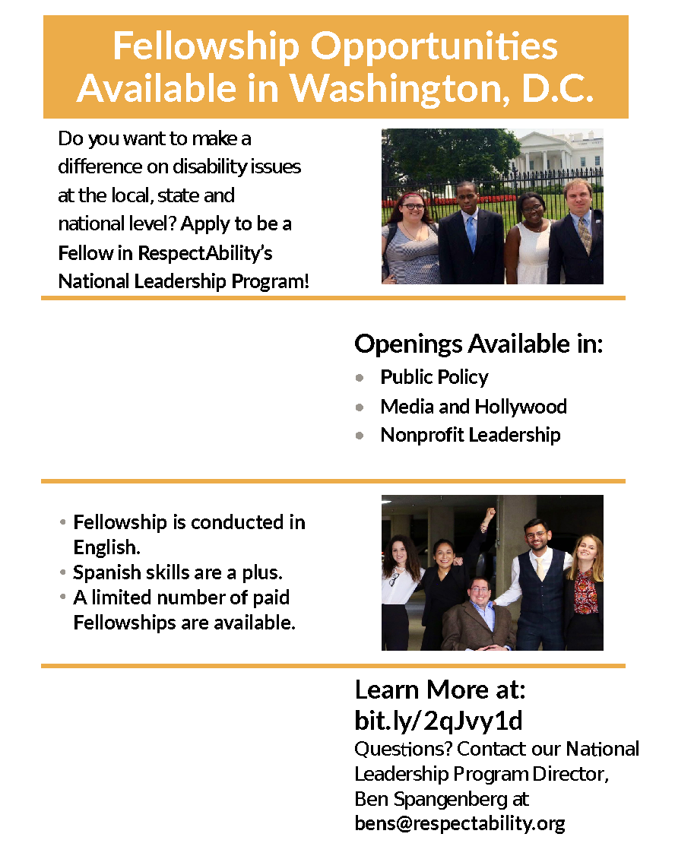

Spanish-Language Resource Team
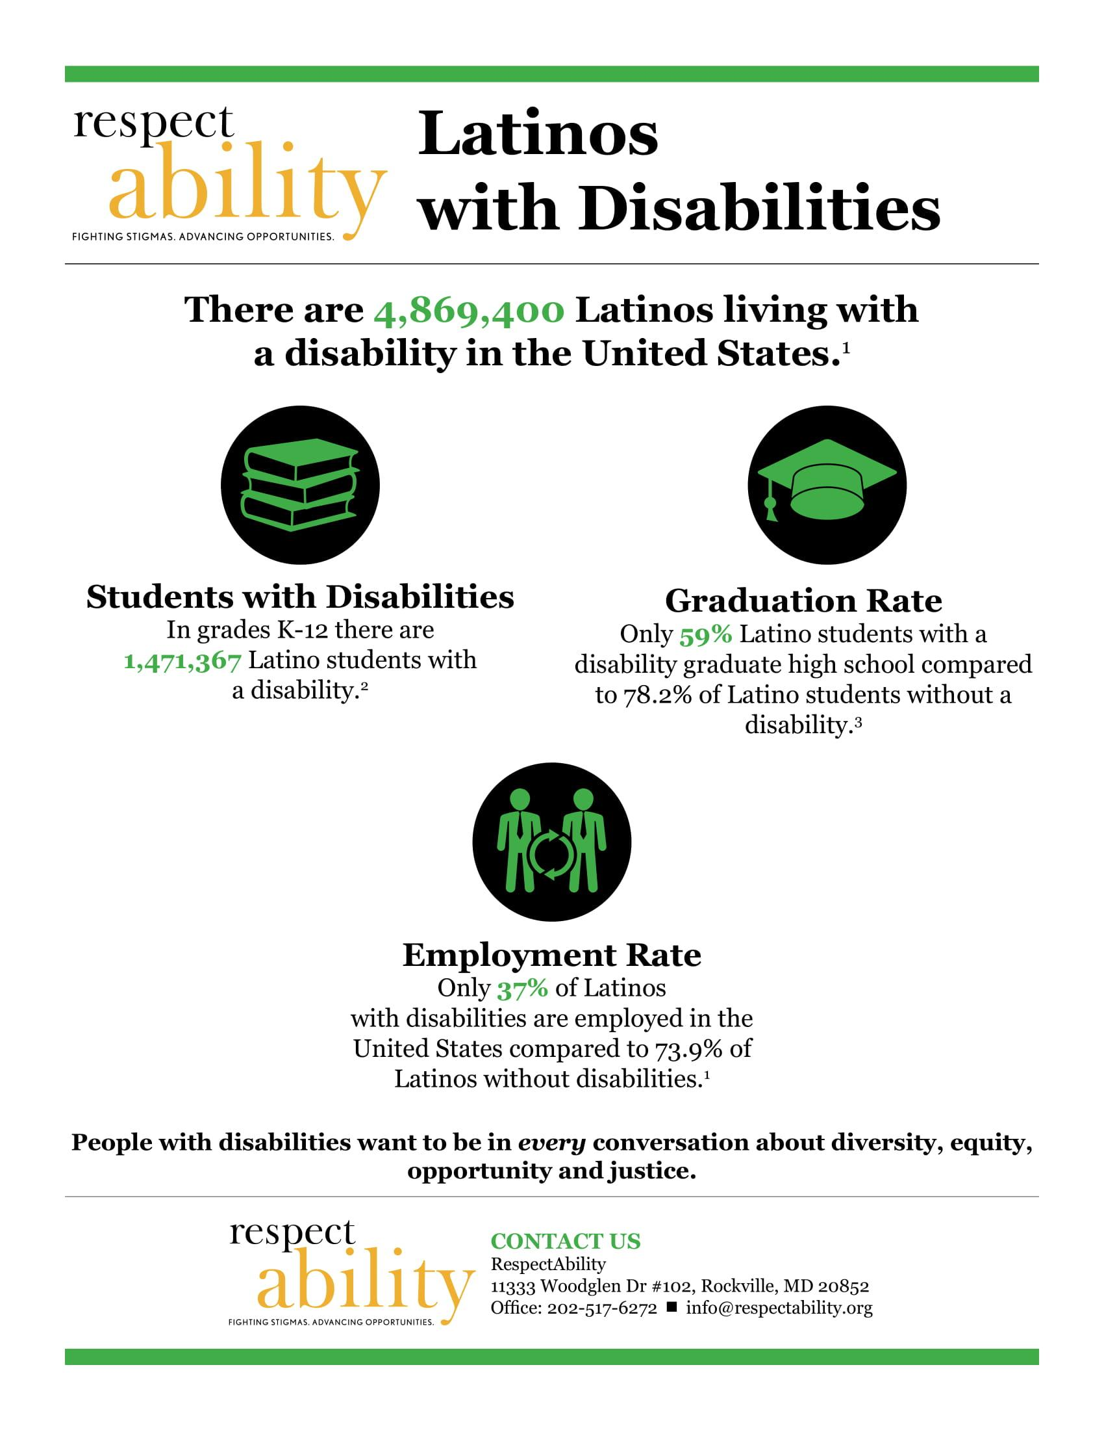
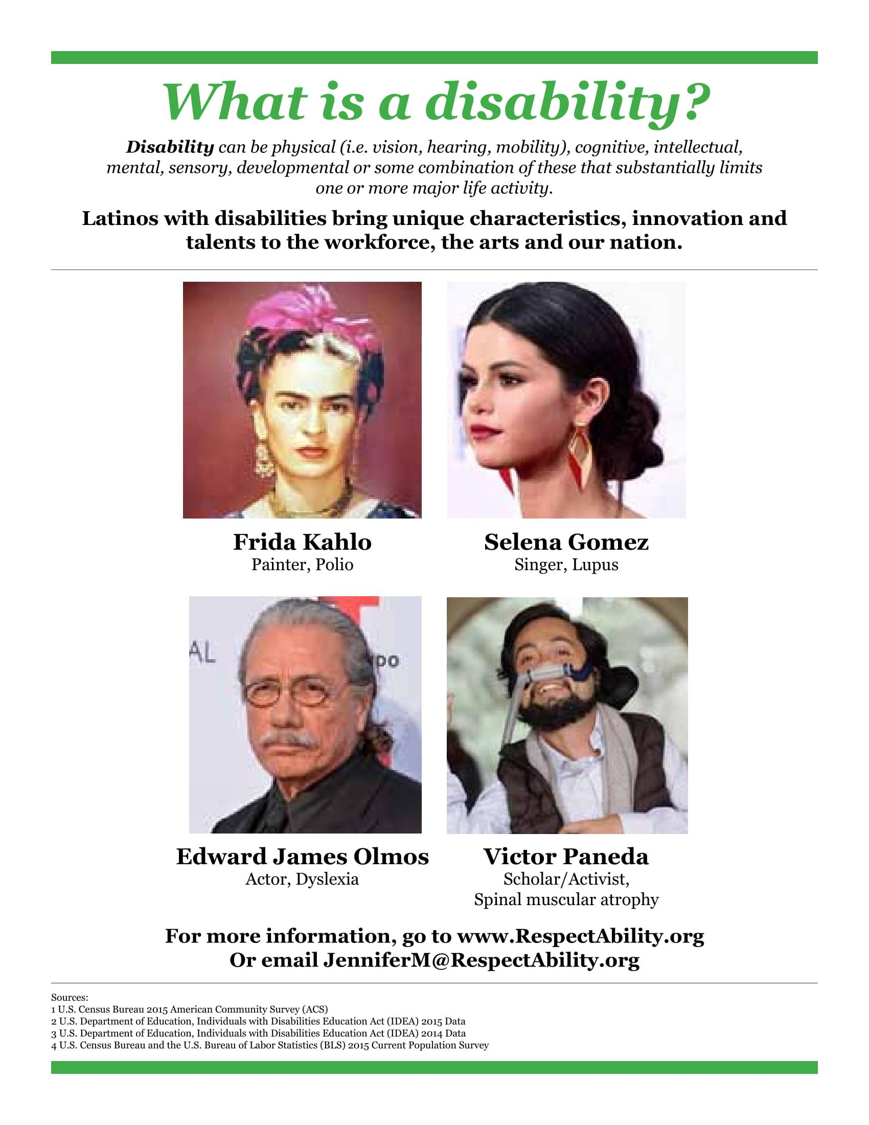

Jewish Inclusion Team
When the Americans with Disabilities Act was passed nearly thirty years ago, it exempted faith-based organizations. Thus, many such organizations do have not yet have the attitudes, physical facilities or training they need to appropriately welcome people of all abilities. Given the very important role that faith and faith-based organizations play in America, RespectAbility is working for full inclusion in all faith groups. However, it has started its faith-based inclusion work with a focus on the Jewish community and institutions. As model practices are established, we will work broadly across faiths to share best practices.
RespectAbility understands that the Jewish community, like all communities, is stronger when it lives up to its values – when it is welcoming, diverse, moral, and respects each other. We want children, parents, grandparents, friends, and other family members with disabilities to be able to fully participate in their communities. We know that many people with disabilities are having a challenging time gaining access to our agencies, synagogues and community. To accomplish this, we work with frontline leaders from dozens of nonprofit Jewish organizations, agencies and synagogues to find and disseminate the best practices, ideas and contacts that will create success.
A Slingshot-recognized organization, RespectAbility is on the front lines – working to ensure that everyone knows that his or her presence and participation is welcomed and meaningful. Below are free resources for all who care about inclusion and equal opportunity.
To view the Jewish Inclusion Toolkits, including the High Holiday Synagogue Toolkit and the Jewish Synagogue Inclusion Toolkit, as well as Jewish Inclusion webinars, visit here: www.respectability.org/resources/faith-inclusion.

Volunteer Forms
The following four forms must be completed prior to beginning your volunteer work with RespectAbility:
- Volunteer Confidentiality Form
Volunteer Emergency Contact Form
Receipt of Volunteer Guidebook Acknowledgement Form
Photo and Audio Release Form
The following two forms must be completed on an ongoing basis during your volunteer work with RespectAbility. Both will soon be available for completion on-line, on our website.
- ‘Volunteer Hours–to–Track’ Form (we request this be completed every month)
This form will soon be available for completion on-line, on our website
‘Volunteer Valuation’ Form (we request this be completed every 3 months)
This form will soon be available for anonymous completion online, on our website

We wish to express our ‘attitude of gratitude’ for your civic engagement and involvement as a volunteer in the RespectAbility team!
For More Information:
Ben Spangenberg, Bens@RespectAbility.org
www.RespectAbility.org

Volunteer Confidentiality Form
This Agreement is made and entered this _____ day of ______________, 2021 by and between RespectAbility, a District of Columbia nonprofit corporation (“RespectAbility”) and __________________________________ (hereinafter called “Volunteer”).
(NAME)
In consideration of Volunteer’s participation in RespectAbility’s unpaid Volunteer Corps Program, it is agreed as follows:
- Volunteer understands and agrees that this volunteer role and service are unpaid. Volunteer will not receive any other payment, compensation or benefits of any kind.
- "Confidential Information" shall be defined for the purpose of this Agreement as information (a) disclosed to the Volunteer by RespectAbility or other employees, consultants, officers or agents of RespectAbility, or known or gathered by the Volunteer as a consequence of or through or in the course of performing services for RespectAbility and (b) not generally known to the public, about RespectAbility's activities, plans, strategies, budget, and operations, including but not limited to studies, reports, advertisements, samples, and programs, data, figures, projections, costs, methods of operation, identity of plans or administrative services, estimates, donor, supporter and allies lists, personnel history, financial statements, accounting procedures and communications, advocacy and organizing techniques, in whatsoever form, whether written, oral, electronic or otherwise, and in whatsoever media, whether in paper form, video or audio tape, disc or otherwise that have not been made public by the organization.
- Volunteer agrees that they will not at any time, whether during the term of his or her service as Volunteer with RespectAbility or after the termination thereof, directly or indirectly disclose any Confidential Information to any person, firm or corporation except for employees of RespectAbility with a need to know such Confidential Information.
- Volunteer agrees that they will not at any time, whether during the term of his or her service as Volunteer with RespectAbility or after the termination thereof, make use of any Confidential Information for any purpose whatsoever other than as needed for the performance of services for RespectAbility by Volunteer.
- Any and all writings, materials, audiovisual works and other works, in any form whatsoever, whether written, electronic or otherwise, created or produced by Volunteer in the course of its performance of services for RespectAbility shall become and remain the exclusive property of RespectAbility and shall be deemed works made for hire created for RespectAbility for purposes of the Copyright Law of 1976; and all copyright and any other rights in and to such writings, materials and works shall belong to RespectAbility. To the extent any such work does not constitute a work made for hire, Volunteer agrees to execute and deliver any instrument of conveyance or any other instrument or document necessary to transfer all such rights to RespectAbility.
- Volunteer further agrees that they will not, during his or her time serving RespectAbility, or at any time thereafter, interfere with or disrupt, or attempt to interfere with or disrupt, any business relationship, contractual or otherwise, between RespectAbility and any other party, including clients or employees, or prospective clients, suppliers, consultants, agents, or the employees of RespectAbility.
- Volunteer acknowledges that all documents, words, files, government official, activist, leadership and media contact lists, information and data in his or her possession or custody, whether gathered by the Volunteer or any other person, and whether or not reduced to writing, or to any electronic or magnetic medium, relating to the business activities of RespectAbility are and shall remain the sole and exclusive property of RespectAbility unless they are publicly offered by RespectAbility.
- Volunteer agrees that, upon the termination of his or her service as Volunteer, irrespective of the time, manner or cause of said termination, the Volunteer will surrender to RespectAbility all Confidential Information in whatsoever form, written or otherwise, all other writings, materials and works described in paragraphs 4 and 6 hereof, and all other information about RespectAbility's clients, contacts, plans, projects, operations and activities, and all copies thereof, as well as any other property of RespectAbility.

In witness whereof, the parties hereto have caused this Agreement to be duly executed as of the date first above written.
RESPECTABILITY

Name: _______________________________

Title: ________________________________ Date: ____________

VOLUNTEER:

Name: _______________________________

Signature: ____________________________ Date: ____________

Emergency Contact Form
My Name: _______________________________________________________

In the case of an emergency, please notify the following person/persons on my behalf:
Name: __________________________________________________________
Home Phone: ____________________ Cell Phone: ______________________
Work Phone: _____________________ Email: _________________________
Preferred Language: _______________________________________________

Name: __________________________________________________________
Home Phone: ____________________ Cell Phone: ______________________
Work Phone: _____________________ Email: _________________________
Preferred Language: _______________________________________________

Do you have any allergies or conditions you want to make us aware of in case of emergency? __________________________________________________
________________________________________________________________

Receipt of Volunteer Handbook Acknowledgement Form
I have received my RespectAbility Volunteer Handbook. I understand that it is my responsibility to become familiar with the information in this handbook.
I have no questions regarding the contents of the handbook and I understand all of its provisions and agree to be bound by them as a condition of my volunteer service.
I will bring with me to my volunteer service a set of values that will create a positive work environment for me and for my fellow co-workers. I will show respect and acceptance towards each person by lending a helping hand for my personal success, the success of others, and the success of RespectAbility.
In order to fulfill my volunteer service to the best of my abilities, I request / require (circle one) the following accommodations (feel free, but not obligated, to disclose any disability):
________________________________________________________________________________________________________________________________________________________________________________________________________________________________________________________________________________________________________________________

_________________________________
Printed Name of Volunteer

_________________________________ Date: ______________________________
Volunteer Signature

Photo and Audio Release Form
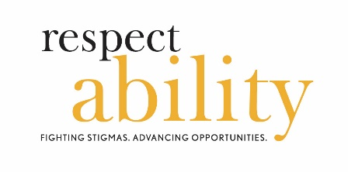
I hereby grant permission, without reservation, to RespectAbility (“RespectAbility”) to take and to use photographs and/or sound/image recordings of me, to describe and to use the same for promotion of good will, public education, and/or fundraising and other related activities of RA, and I waive any right to inspect or approve the photograph(s) or finished version(s) of works, including website, incorporating the photograph(s).
I release RespectAbility, its officers, directors, agents, employees, independent contractors, licensees and assignees (including photographers), from all claims that I may have or might have, for any cause of action arising out of taking and/or use of the photographs and/or any sound/image recordings, and/or description of the same, be it blurring, distortion, alteration, optical illusion, or use of composite form whether intentional or otherwise, that may occur or be produced in taking of the photographs, or any processing tending toward the completion of the finished product, unless it can be shown that they and the publication thereof were maliciously caused, produced and published solely for the purpose of subjecting me to conspicuous ridicule, scandal, reproach, scorn and indignity.
I agree that RespectAbility owns the copyright (or may apply for copyright) in these photographs and other works and creations, and I hereby waive any claims I may have based on any usage of the photographs or works derived there from in any form, may it be printed, projected, televised or transmitted via the web, and/or at any time, be it in the present or in the future, including, but not limited to claims for either invasions of privacy or libel.
I am of full age and competent to sign this release. I agree that this release shall be binding on me, my legal representatives, heirs, and assigns. I have read this release and I am fully familiar with its contents.

____________________________________________________________________________
NAME (or NAME of MINOR)
____________________________________________________________________________
ADDRESS
_____________________________________________________________________________
SIGNATURE (if minor, signature of parent or legal guardian) DATE

Volunteer Valuation Form
(to be completed every 3 months)
Thank you for volunteering with us! We value your contributions, and recognize that we all learn from one another. To this end, thanks for completing this anonymous “Volunteer Valuation” form. (Should you choose to add your name, we may follow up for more in-depth debriefing with you.) We appreciate your candor. Respectfully yours, the RespectAbility staff.
- When (month/year) did you start volunteering? ________________________________

- How many hours do you volunteer per week? ~_______ Per month? ~__________

RANKING BELOW: Please CIRCLE the number that most applies: 1 = The Least; 5 = The Most.
C) How meaningful do / did you find your volunteer work? (1= not meaningful; 5= very meaningful)
1 2 3 4 5
- How easy is / was it to receive required training? (1= difficult; 5= very easy)
1 2 3 4 5
- Do / did you find yourself using the training tools? (1= never; 5= always)
1 2 3 4 5
F) How is / was the overall communication with our staff? (1= poor; 5= very excellent)
1 2 3 4 5
G) How available is / was your supervisor in times of need? (1= unavailable; 5= very available)
1 2 3 4 5
H) How respected do / did you feel with the staff? (1= uncomfortable; 5= very comfortable)
1 2 3 4 5

I) How respected do / did you feel with other volunteers? (1= uncomfortable; 5= very comfortable)
1 2 3 4 5
J) Do / did you feel that your needs are / were met? (1= no; 5= yes)
1 2 3 4 5
K) How would you rank your overall experience? (1= dislike(d); 5= love(d))
1 2 3 4 5
M) Do you plan to continue volunteering with us? Yes / No / Maybe (circle one)
If not, why not?
______________________________________________________________________________
What could we be doing to further improve the experience for you and/or other volunteers?
______________________________________________________________________________
______________________________________________________________________________
______________________________________________________________________________
______________________________________________________________________________
Is there anything else you feel we have left out that you would like to share?
______________________________________________________________________________
______________________________________________________________________________
______________________________________________________________________________
______________________________________________________________________________
Feel free to share more . . . and/or, to include your name (name is not required):
______________________________________________________________________________
______________________________________________________________________________

Terminology Tips: Using the Appropriate Lexicon
RespectAbility wants all of our work to be welcoming, respectful and inclusive of all people. Thus, we ask members of our team to learn about inclusion, equity and diversity of all kinds. The use of certain words or phrases can express bias either intentionally or unintentionally. Especially when writing/typing, it is vital to ensure you are using appropriate terminology.
- Disability language style guide: The National Center on Disability and Journalism (NCDJ) provides the industry’s only disability language style guide. The guide is intended for journalists, communication professionals and members of the general public who are seeking the appropriate and accurate language to use when writing or talking about people living with disabilities. The guide covers general terms and words on physical disabilities, hearing and visual impairments, mental and cognitive disabilities and seizure disorders. Please note that many of the language suggestions found throughout this guide are based on these NCDJ guidelines.
http://ncdj.org/style-guide/
- If you are working with individuals with disabilities, ask them their preference. While many professionals within the disability community push person-first language (person with a disability), some individuals with disabilities prefer identity-first (disabled person). While it is generally a safe bet to use person-first language, there are members of certain disability groups in the United States who prefer not to use it. For example, some within the Deaf community prefer the term Deaf while some people who are blind prefer the term “blind.” Likewise, among people on the Autism spectrum, some prefer to be called Autistic people or Autistics. Their reasoning is that they consider their disabilities to be inseparable parts of who they are. Just as you may ask people for their gender pronoun preferences, you should ask people with disabilities you work with how they choose to be identified. The Research & Training Center on Independent Living at the University of Kansas offers a glossary of preferred terms for many visible and invisible disabilities, illustrated with person-first language. Keep in mind, however, that you should ask a person how they want to be identified. It is best to use their personal preference, regardless of if it conforms to guides.
http://rtcil.org/products/media/guidelines#Person-First
- Think about other language that you use. What is considered acceptable language regarding disabilities has changed over time. Standards are changing as understanding evolves. Many once widely used terms now are considered offensive and are taken to imply inferiority or have other negative connotations. Other terms are outdated medical or colloquial terms. Avoid terms like “wheelchair-bound” and “suffers from.” People with disabilities are not “victims.” This companion piece to the National Center on Disability and Journalism’s Style Guide outlines some of the biggest mistakes to avoid.
http://ncdj.org/2015/09/terms-to-avoid-when-writing-about-disability/
- People with disabilities should not be described as “inspirational” or “courageous” just because they have a disability. Inspiration porn is when people with disabilities are called inspirational or brave for doing something as simple as exercising or being invited to a prom. Per the TV show Speechless, “It’s a portrayal of people with disabilities as one-dimensional saints who only exist to warm the hearts and open the minds of able-bodied people.” Inspiration porn assumes that anyone with a disability must have it so much worse, and it uses people with disabilities to make nondisabled people feel good about themselves or to make them do something, like exercise. Falling into this trap leads to stigmatizing disabilities.
- Use the word “disability.” Terms like “physically challenged,” “special” and “differently-abled” can be seen by some as patronizing. Saying "differently-abled" or "special," for instance, may seem on the surface to convey that someone with a disability has positive qualities about them. However, terms like these tend to be euphemistic, and frequently are not used by the people to whom they refer. In addition, people with disabilities are protected under the Americans with Disabilities Act. People with “special needs” are not.
- People without disabilities are not “normal.” Saying “normal” infers that people with disabilities are “abnormal.” While people without disabilities often are referred to as “able-bodied,” some members of the disability community oppose its use because it implies that all people living with disabilities lack “able bodies.” Instead, use the term “nondisabled,” “does not have a disability” or “is not living with a disability.” In some cases, the word “typical” can be used to describe a nondisabled condition.
- Just as we want people to be respectful of people with disabilities, we should be respectful of other differences and minority communities as well. Here are some resources to fight implicit bias and racism.
https://www.respectability.org/resources/racism-unconscious-bias

Common Acronyms
Acronym | Definition
AAC | Alternative Augmentative Communication
ABA | Applied Behavioral Analysis
ADA | Americans with Disabilities Act
ADD/ADHD | Attention Deficit Disorder/Attention Deficit Hyperactivity Disorder
ADLs | Activities of Daily Living
ASD | Autism Spectrum Disorders
AT | Assistive Technology
BD | Behavioral Disorder
BOE | Board of Education
CD | Cognitive Delay
CF | Cystic Fibrosis
COTA | Certified Occupational Therapist Assistant
CP | Cerebral Palsy
DB | Deafblind
DD/ID | Developmental Disability/Intellectual Disability
D/HH | Deaf/Hard of Hearing
DOE | Department of Education
DoH | Department of Health
DS | Down Syndrome
EBD | Emotional Disturbance
ED | U.S. Department of Education
EHDI | Early Hearing Detection and Intervention Program
EI | Early Intervention
ESEA | Elementary and Secondary Education Act
FAPE | Free Appropriate Public Education
FAS | Fetal Alcohol Syndrome
FERPA | Family Educational Rights and Privacy Act
GE | General Education
GT | Gifted and Talented
HL | Hearing Loss
IDEA | Individuals with Disabilities Education Act
IEE | Individualized Educational Evaluation
IEP | Individualized Education Program
IFSP | Individualized Family Service Plan
ITP | Individualized Transition Plan
LD | Learning Disability
LRE | Least Restrictive Environment
MD | Muscular Dystrophy
MD or MH | Multiple Disabilities or Multiple Handicapped
NCLB | No Child Left Behind Act (Elementary and Secondary Education Act)
O&M | Orientation and Mobility Services
OCD | Obsessive-Compulsive Disorder
ODD | Oppositional Defiant Disorder
OHI | Other Health Impairment
OI | Orthopedic Impairment
OT | Occupational Therapist
PBS | Positive Behavioral Supports
PD | Physical Disability
PDD | Pervasive Developmental Disorder
PT | Physical Therapist
PTA | Physical Therapist Assistant
PTSD | Post-Traumatic Stress Disorder
PwDs | People with Disabilities
RTI | Response to Intervention
SB | Spina Bifida
SE | Special Education
Section 504 | Section 504 of the Rehabilitation Act
Section 508 | Section 508 of the Rehabilitation Act
SED | Serious Emotional Disturbance
SI | Sensory Integration
SLI | Speech/Language Impairment
SLP | Speech/Language Pathologist
SLPA | Speech/Language Pathologist Assistant
SSDI | Social Security Disability Income
SSI | Supplemental Security Income
TBI | Traumatic Brain Injury
TDD | Telecommunication Devices for the Deaf
TS | Tourette Syndrome
TTY | Teletypewriter (Telephone System for Individuals With Hearing Impairments)
TWWIIA | Ticket to Work and Work Incentives Improvement Act
VI | Visual Impairment
Voc Ed | Vocational Education
VR | Vocational Rehabilitation

Etiquette: Interacting With People With Disabilities
- People with disabilities are human. Acknowledge their differences as you would acknowledge anyone else’s uniqueness and treat them “as normal.” Refrain from talking down to them literally or figuratively. If they use a wheelchair, use a chair to be on their same eye level if you are having a long conversation.
- Put the person first. Say “person with a disability” rather than “disabled person.” Say “people with disabilities” rather than “the disabled.” For specific disabilities, saying “person with Tourette syndrome” or “person who has cerebral palsy” is usually a safe bet. Still, individuals do have their own preferences. If you are not sure what words to use, ask. Avoid outdated terms like “handicapped,” “crippled” or “retarded.” Please see more details on this point in our “Terminology Tips: Using the Correct Lexicon” section.
- Speak directly to a person with a disability, not to their companion or sign language interpreter. A lack of immediate response does not indicate that the person can’t or won’t respond.
- Adults with disabilities are adults and deserve to be treated and spoken to as adults. It’s best to avoid making decisions for them. Do not tell them what to do or use baby talk. Provide them with every option you provide those without disabilities. If the option they choose presents a difficulty concerning their disability, discuss ways you could modify or adapt the choice.
- If you are unsure of how you should interact with a person with a disability, just ask them. Just because someone has a disability it is best to not assume they need help. People generally prefer if you refrain from giving assistance without asking first if they want it. You can ask if the person would like help, but don’t ask repeatedly or qualify their response with “are you sure?” Respect someone’s choice even if it looks like they’re struggling. If there is a dangerous situation, help just as you would help someone without a disability.
- A person’s mobility equipment, such as a wheelchair, scooter or cane, is part of his or her personal space. It is best to not touch or move it without permission, even if someone puts it down or chooses to leave it somewhere. Leaning on someone’s wheelchair is like leaning on his or her shoulder. Putting something in someone’s carry basket is like putting something in his or her backpack. It is vital that the owner knows where his or her equipment is at all times.
- Listen attentively when you are talking with a person who has difficulty speaking. Be patient and wait for the person to finish, rather than correcting or speaking for the person. If necessary, ask short or close-ended questions that require short answers, a nod or shake of the head. Never pretend to understand if you are having difficulty doing so. Instead, repeat what you have understood and allow the person to respond. The response will clue you in and guide your understanding.
- People who have psychiatric disabilities may have varying personalities and different ways of coping with their disability. Some may have trouble picking up on social cues; others may be supersensitive. One person may be very high energy, while someone else may appear sluggish. Treat each person as an individual. Ask what will make them most comfortable and respect his or her needs to the maximum extent possible.
- There are visible disabilities as well as invisible disabilities, meaning not all disabilities are apparent. A person may make a request or act in a way that seems strange to you. That request or behavior may be disability-related. For example, you may give seemingly simple verbal directions to someone, but the person asks you to write the information down. They may have a learning disability that makes written communication easier. Even though these disabilities are hidden, they are real.
Please note it is considered offensive to pretend to have a disability, and disability simulation experiences should be done for design/navigational purposes only.
Learn more by reading the United Spinal Association’s Disability Etiquette booklet: https://unitedspinal.org/disability-etiquette/.

