Ensuring Virtual Events
Are Accessible for All

Written and Compiled By:
RespectAbility
Lauren Appelbaum and Eric Ascher
www.RespectAbility.org

May 20, 2020

Table of Contents
Table of Contents iii
Introduction 1
Before the Event 2
Creating and Sending Invitations 2
Ensuring Accessible Documents 3
During the Event 3
Ensuring Everyone Can Participate Including Those Who are Blind, Have Cognitive Disabilities and/or are Nonverbal 3
Live Captioning 4
ASL Interpreters 5
After the Event 6
Ensuring Accessible Videos for Websites and Social Media 6
A Note About Instagram 7
Contact Information 7

Introduction
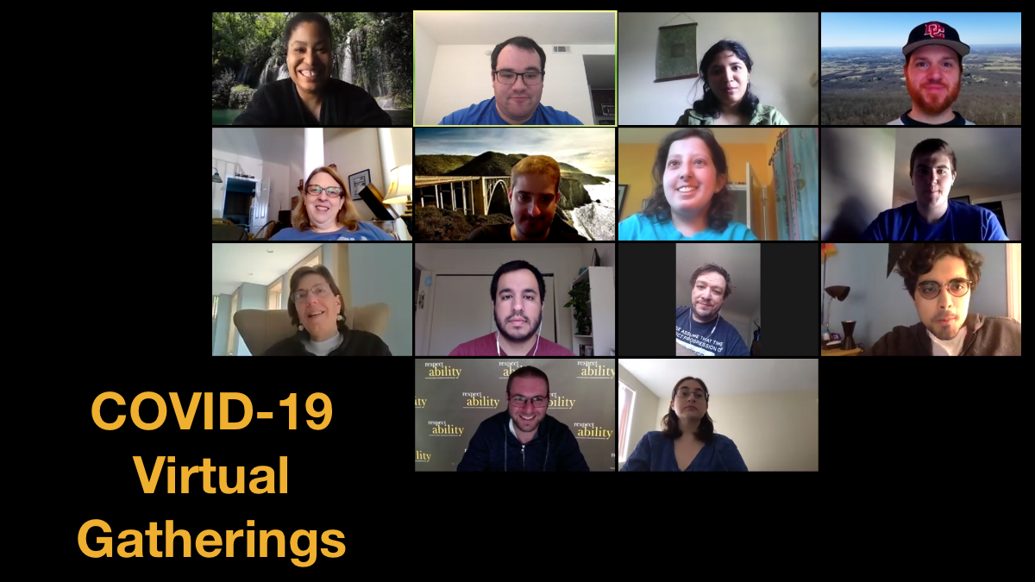
The COVID-19 pandemic is causing organizations to transition many events and conferences that originally were in-person to virtual ones. The good news is that it is easy to make online events accessible to everyone if you know how.
Ensuring accessibility during the planning process of an event is important, as if you are planning to post a video of the event after the fact, you may need to ensure accessibility during the actual event, even if no live participants request one. This is important for several reasons:
- Twenty percent of people in the U.S. are Deaf/Hard of Hearing; that is 48 million Americans.
- More than 1 million people in the U.S. are blind and more than 12 million have low vision.
- More than 5 million people in the U.S. are English language learners.
While not everyone knows they have one, it is likely that more than 40 million Americans have a learning disability.
It is vitally important to think through every step and every use of the event before implementing anything. After all, it always is easier to make changes during the planning stages than after the fact.
Below are some steps you should take before, during and after your event to ensure it is as accessible as possible for all people.

Before the Event

Creating and Sending Invitations
During this pandemic, most event invitations are being sent via email and/or posted to social media. While email invitations may have multiple graphical elements, ensure that images and logos have alt text – image descriptions – for people who are blind and use screen readers. In addition, it is best practice to have an option for someone to click through to a plain text version of the invite for individuals with a variety of disabilities. Please note that some systems, like Eventbrite, are not accessible to people who are blind or have low vision. Learn more about ensuring website accessibility: https://www.respectability.org/2020/01/how-to-ensure-accessible-websites-social-media-and-inclusive-photos.
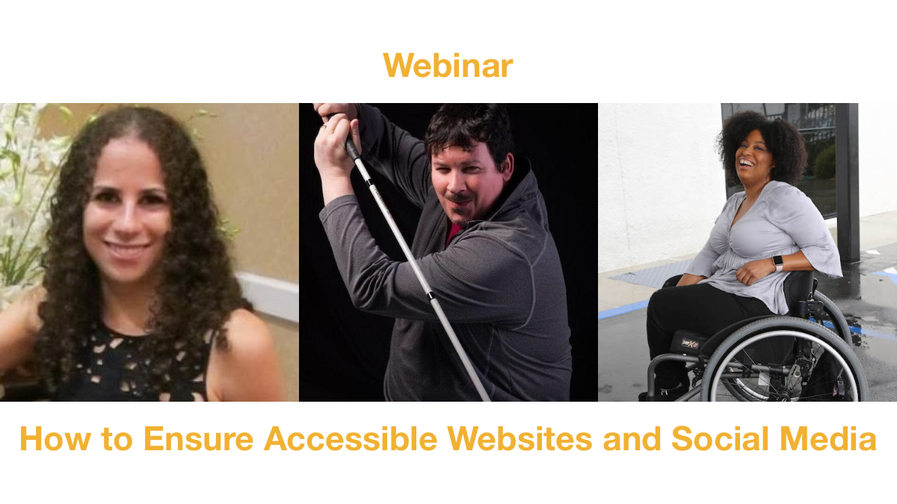
On the sign-up form, ask registrants if they need any accommodations to effectively participate in the event. Additionally, provide a name, email and phone number for someone who can assist people with any accommodation’s request. Depending on the size and budget of your organization, it may be fair to set a deadline of 48 hours before the event to request any accommodations. By offering people the option to request accommodations, it does not require you to provide every accommodation requested if your organization is too small to accommodate everything. However, having open communication with individuals requesting accommodations is important, as they may have ideas for workarounds that are doable for your event. Luckily, ensuring accessibility for online meetings is free or very inexpensive.
The invitation also should list how long the event will last as well as what the format of the event will be. Will participants be on video or audio for discussion or will they be more like spectators watching a presentation? If there will be an icebreaker or questions for everyone to answer, let attendees know that ahead of time. Encourage attendees to send questions or comments in advance, which is helpful not only to participants who may want more time to prepare their materials but also to the presenters to help them frame their comments. If there will be time for live Q&A, share that information in the invitation.
It also is important to have an accommodation for individuals who do not have access to video conferencing. By offering the option for attendees to dial in by phone, people with and without disabilities who do have internet access can still participate.

Ensuring Accessible Documents

If you are using any documents or a Microsoft PowerPoint presentation for your online event, distribute it to your attendees in advance. That way, attendees who are blind or have low vision can use screen reader software to familiarize themselves with the materials being presented. PowerPoint has a built-in tool to check accessibility issues in your slide deck and gives you instructions on how to fix them. For help on how to use it, visit the Microsoft Office Support Site: https://support.office.com/en-us/article/make-your-powerpoint-presentations-accessible-to-people-with-disabilities-6f7772b2-2f33-4bd2-8ca7-dae3b2b3ef25. For Word documents, we recommend having a text-only version for people who request one.

During the Event

Ensuring Everyone Can Participate Including Those Who are Blind, Have Cognitive Disabilities and/or are Nonverbal
During events where multiple people are speaking, the best practice is for each person to say their name every time they begin speaking. This helps people with a variety of disabilities, including people who are blind or have low vision, as well as individuals with cognitive disabilities.
The larger the event, the more organization is needed. For events where everyone is visible and able to speak, any individual not speaking should be on mute and a moderator is needed to manage turn-taking. A noisy meeting environment increases listening processing and fatigue for everyone; keeping yourself on mute when not speaking helps all participants.
For people who are nonverbal, it is important to give them an option to share their thoughts if others are doing so verbally. One way to do so is to ensure the moderator or host reads notes made in the chat box out loud to everyone. The moderator or host should announce this as an option for people to do.
In order to help people with different types of disabilities, when someone is not speaking, they also should turn their video off. A host of a Zoom meeting is able to unilaterally turn off the video of participants. The sign language interpreter video should always be on.
Depending on the length of the event, consider having breaks for people to both have time to process information and use the restroom. It is recommended to have a 10-minute break every hour or so.
If there is a PowerPoint or other visual aid, then the speaker should describe what is on screen to accommodate individuals who are blind or low vision. Even if you made the PPT accessible, people will not be able to use screen readers for the PPT being shown on screen – only if they are sent their own copy to use. Therefore, the speaker should describe what it on screen before delivering any other talking points. If video clips that do not include audio description are played during a presentation, the speaker should explain the visuals before the video begins.
This is important not only for participants who are blind but also because it is unlikely that audio description, which is narration describing what viewers see on screen, can be added after-the-fact to a fast-paced virtual meeting. We recommend this great guide to audio description, including examples: http://www.superfestfilm.com/audiodescription.

Live Captioning
The gold standard of captioning is Communication Access Realtime Translation or CART, where a live transcriber types what is spoken in real time. RespectAbility currently uses Zoom for our webinars (including prior to this current climate), which is screen reader accessible. RespectAbility events always include CART. Other platforms that support live captioning include: Adobe Connect and Webex. This involves utilizing a third-party closed captioning service. Thankfully, there is not a shortage of companies that provide this relatively inexpensive service. Below, please find a resource list that was compiled by RespectAbility Fellow Baksha Ali:

- 1CapApp: https://www.1capapp.com, 866-945-0250
- StreamText: http://StreamText.net, 608-234-4759
- Transcription Star: www.transcriptionstar.com, 877-323-4707
- Closed Captioning Services: ccscaption.com, 818-775-0410
- 20/20: www.2020captioning.com, 800-870-1795 ext. 1
- Alternative Communication Services: www.ascaptions.com, 800-335-0911 ext. 705
- A La CARTe Connection: https://alacarteconnection.com, 888-900-3239
- CART Agency: http://cartagency.com, 877-871-2654
- Captions Unlimited: https://captionsunlimited.com, 775-746-3534

In addition to live CART, technology is rapidly catching up and now a handful of high-quality automatic speech recognition (ASR) options exist. While Bluejeans, Google Hangouts Meet, GoToMeeting, Microsoft Teams and Skype offer automated captioning, there is no support for live captioning. Furthermore, the automatic live captioning may be limited. Skype’s free captioning for video chats, for example, is limited to up to 50 people, restricting captioning for larger meetings behind a paywall. Google also limits its ASR captioning to its paid G-suite customers. Google Slides and PowerPoint both also have an automatic live captioning option, but they do not work as well if the person sharing the PowerPoint is not the one speaking. In addition to supporting CART, Zoom allows for integration with Otter, a popular speech-to-text app with high quality ASR, but only for paid Zoom accounts. While ASR can make accessibility both free and instant, please be aware that automatic live captioning will have some errors, especially if the content includes very specific vocabulary, like complex medical terms. If they are provided with the information ahead of time, a live captionist will be aware of names, proper nouns and technical vocabulary. In addition, unlike ASR, a live captionist can fill in the gaps with contextual clues if the audio is poor. This includes viewing presentation materials for support. In addition, a live captionist can let participants know if they are speaking too softly or too many people are speaking at once. Especially when using ASR, background noise must be minimized, with only one speaker at a time.

Any platform can utilize the services of a live captioner with a third-party captioning service. With this option, captions are displayed in a separate browser window. Services such as StreamText and 1CapApp also allow for customization in how an individual views the captioning.

We recommend viewing this chart compiled by Connect-Hear.com: http://connect-hear.com/knowledge-base/chart-of-videoconferencing-captioning-availability.

CART, ASR and non-embedded captions can be useful for a few different audiences, including people who are Deaf/Hard of Hearing, people who have learning disabilities who have an easier time comprehending the written word, and people whose first language is not English. CART greatly eases the cognitive load of a video meeting or event.

It is important to note, however, that captioning solutions may not always work best for the Deaf/Hard of Hearing viewer. For example, those that participate via mobile devices, or through small screens, may find it difficult to read the small-sized captions, particularly for a lengthy period of time. Some platforms allow users to increase the size of their captioning, which may or may not be helpful in addressing this issue.

ASL Interpreters

Live captioning may work well for forward-facing events, where participants are mainly watching, but it must be noted that if the Deaf/Hard of Hearing individual does not use voice chat, they will be limited to using the platform’s text chat function which, depending on the organization’s customary videoconferencing practices, may not be tracked as closely as voice chat. For meetings and events where participants are actively engaged in interactive discussions, some Deaf/Hard of Hearing individuals would prefer having an ASL interpreter over live captioning in order to ensure their active participation. In addition, for events that involve complex subject matter, technical terms, or industry-specific terminology, viewers will find that automatic captioning, and in some cases, even live-captioning solutions, struggle to maintain a reasonable minimum level of quality and legibility for the user. The Sign Language Company (https://signlanguageco.com, 818-728-4241) provides Zoom interpreting. Event organizers need to email the log-in information to the interpreter with a link or an invite to the room. They also should share names of speakers and any PowerPoints ahead of time so the interpreters can become familiar with the materials.

Specifically for Zoom, when utilizing ASL interpreters, it is important to never spotlight a video. Doing so leads to all attendees only seeing the video of the active speakers. However, this then also means that attendees are unable to view the ASL interpreter’s video. Instead, ensure that the meeting or event is set to gallery view. When screen sharing, ensure the vide gallery is set to side-by-side view; otherwise, participants will only see the screen share and the person speaking and not the ASL interpreter. If recording an event on Zoom, the view that is active at the time the recording is started determines what the recorded view will look like for the remainder of the meeting, even if the view is later changed. This also means that auto-recording in the meeting options is not an appropriate setting – it could result in recording only the host and no one else.
When hiring a sign language interpreter through a service, do so as early as possible. Two weeks is recommended. Be sure to confirm that the sign language interpreter is certified and experienced, and let the interpreter know if the event will be shared publicly. A certified interpreter is someone who has met a minimum of hours of training on a regular basis and abides by a code of professional conduct. This is important to ensure that your communications, and the conduct of the interpreter(s), meet the appropriate quality, ethical and professional standards. The Registry of Interpreters for the Deaf (RID) maintains a searchable directory of interpreters and their certification status.

After the Event

Ensuring Accessible Videos for Websites and Social Media
Forty-one percent of videos are incomprehensible without sound or captions. In fact, 80 percent of viewers react negatively to videos autoplaying with sound. So now, many social media outlets autoplay videos on silent. Therefore, if you record your event and plan on sharing the video, it is crucial that you have accurate captions.
Since many people confuse subtitles and captions, so here is the difference:
- Subtitles only reflect what is being spoken.
- Captions go a step further by also including non-spoken information including [laughter], [applause] and [music], as well as environmental sounds.
Open captions are always visible. This is important for videos that will be posted on social media channels, as 85 percent of Facebook videos are watched without sound. Similar statistics exist for other social media platforms. 92 percent of mobile users watch video with the sound off.
Closed captions can be turned on/off by the viewer on TVs as well as on social media platforms. With modern web services like YouTube, closed captioning is easy to implement. If your video is hosted on YouTube and has good sound quality, basic captions similar to subtitles will automatically be added to your video at no charge. The captions are never perfect. Speakers will not be identified, certain words will not be accurate, and there will not be any punctuation. Furthermore, things like laughter and applause will not be mentioned. In order for your video to be accessible for people who are Deaf/Hard of Hearing, it is vitally important to review automatic captions and fix these issues.
There are step-by-step guides on YouTube’s help section that will tell you everything you need to know about captions on YouTube including how to edit captions that need fixing, as well as how to upload a transcript and have YouTube create captions from the transcript. If your uploaded video is short and has poor audio quality, the help section details how to create captions from scratch. Here is an excerpt about how you can review automatic captions and edit them:
- Go to your Video Manager by clicking your account in the top right > Creator Studio > Video Manager > Videos.
- Next to the video you want to add captions or subtitles to, click the drop-down menu next to the Edit button.
- Select Subtitles and CC.
- If automatic captions are available, you'll see Language (Automatic) in the "Published" section to the right of the video.
Review automatic captions and use the instructions to edit or remove any parts that haven't been properly transcribed.
Even if you do not end up hosting your video on YouTube, you can still use their captioning service. Simply upload your video to YouTube, have the service create the captions automatically, go in and fix them, and then download a SubRip (SRT) file. SubRip is the standard file format for captioning, and you can upload an SubRip file to services like Vimeo or Facebook to enable captions on these platforms.

A Note About Instagram

If you are posting content on Instagram, stories and videos can easily be made more accessible with captions. For Insta Stories, captions can be added in two ways: by downloading and utilizing a free app like Clipomatic or recording the video and manually typing what is being said using the add text option. For videos on feeds, the best way to add captions are by prerecording the video and adding captions in editing software such as Inshot, Screencast-O-Matic, Adobe Premiere Pro, Final Cut or iMovie.

Contact Information

Have more questions about how to ensure accessibility of your virtual meetings? Contact us! If we don’t know the answer, we’ll find someone who does and put you in touch. Please contact EricA@RespectAbility.org with your request.

